History WC 25th January 2021
LI: To recall and remember facts about how the Great Fire of London Started
I can talk about how a fire would start.
I can talk about what the houses were made from in 1666
I can talk about how the fire spread from house to house.

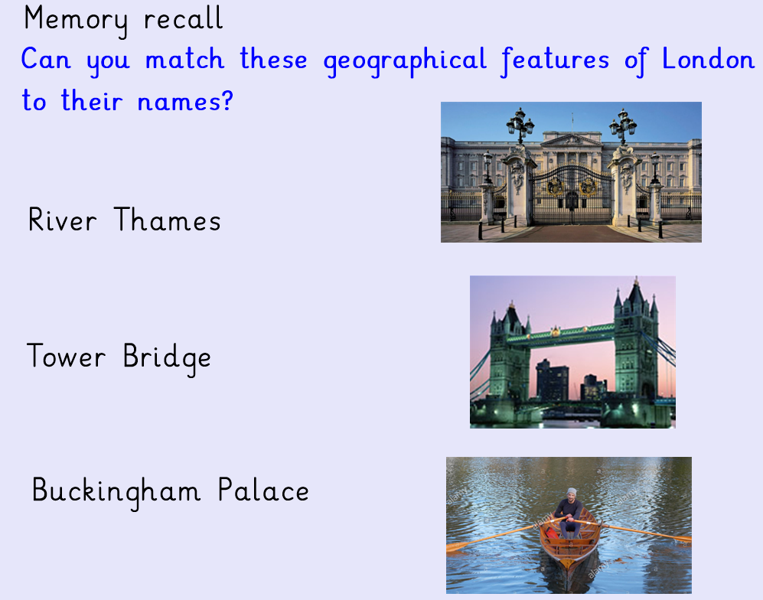

If you have a laptop or tablet at home you can login to play the Great Fire of London game.
http://www.fireoflondon.org.uk/game/
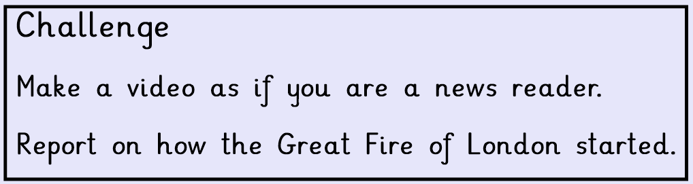
REMEMBER – to use the success criteria grid above to help you remember what facts you need to remember.

