Wednesday 3rd February
Instructions
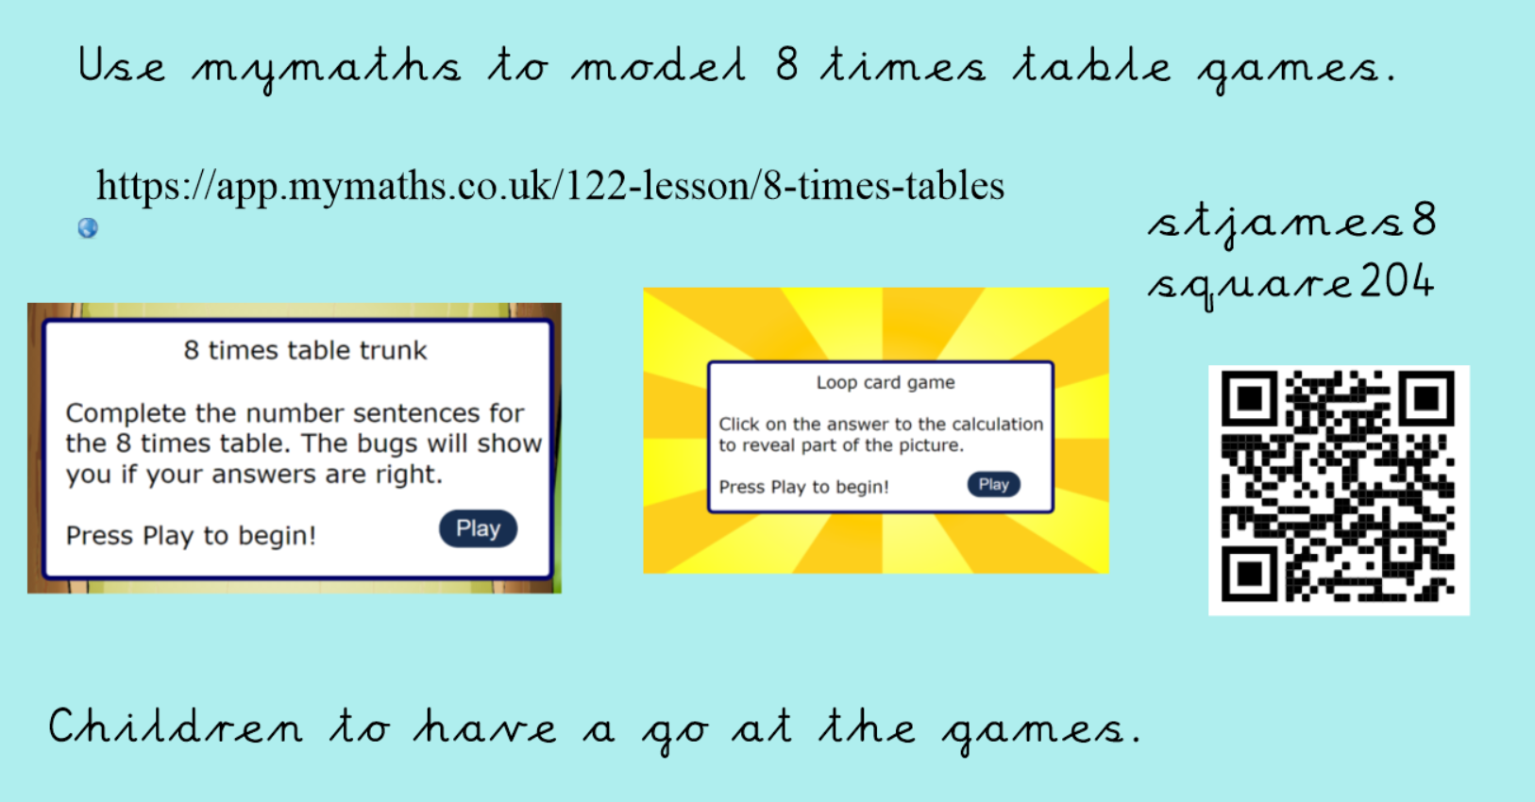
Use the QR code to take you straight to the mymaths page that you need or log in to mymaths using the details above and got to number, multiplication and division, Year 3 8 times tables.
Have a go at playing the games.

