Wednesday 13th January
Maths Instructions
Read through these slides and follow the process for dividing by 10 and 100 when there is no zero at the end of the given number.
If you need further support, please watch the loom videos on the school website – Home Learning, Year 3 and 4, Spring 1 week 2
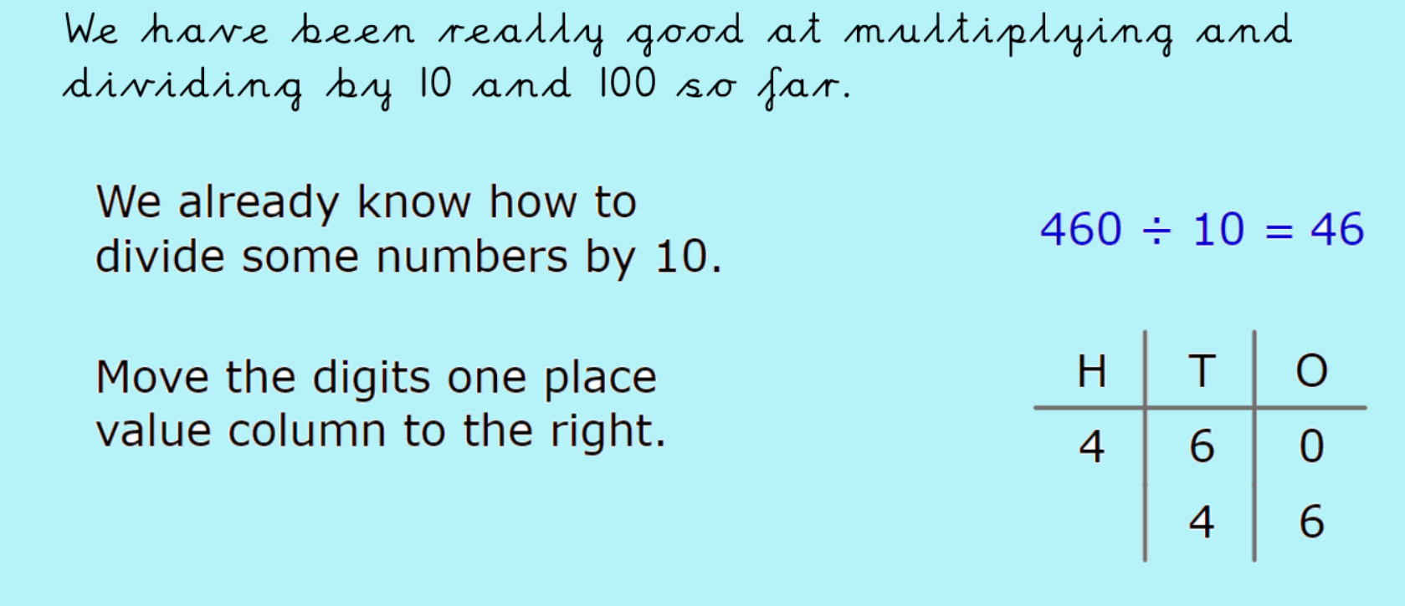
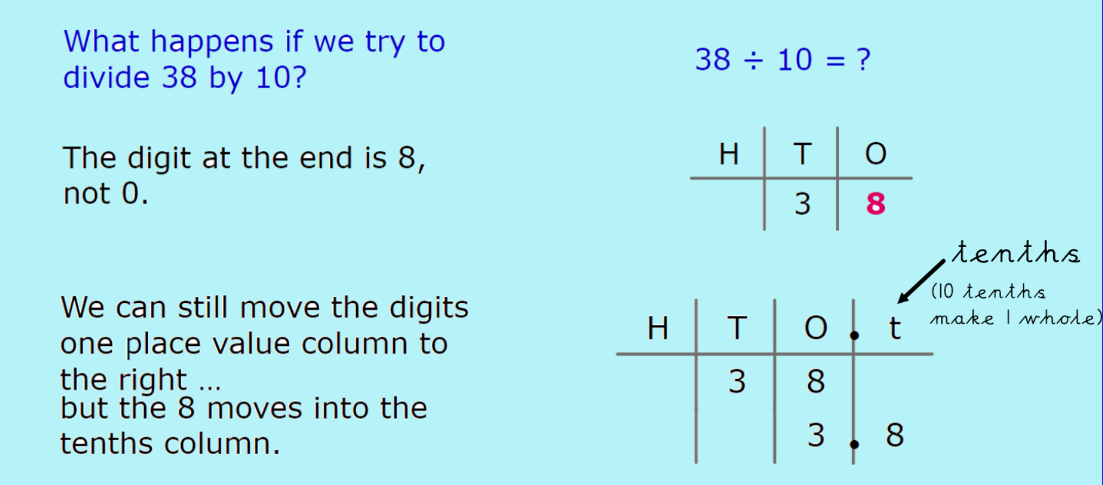
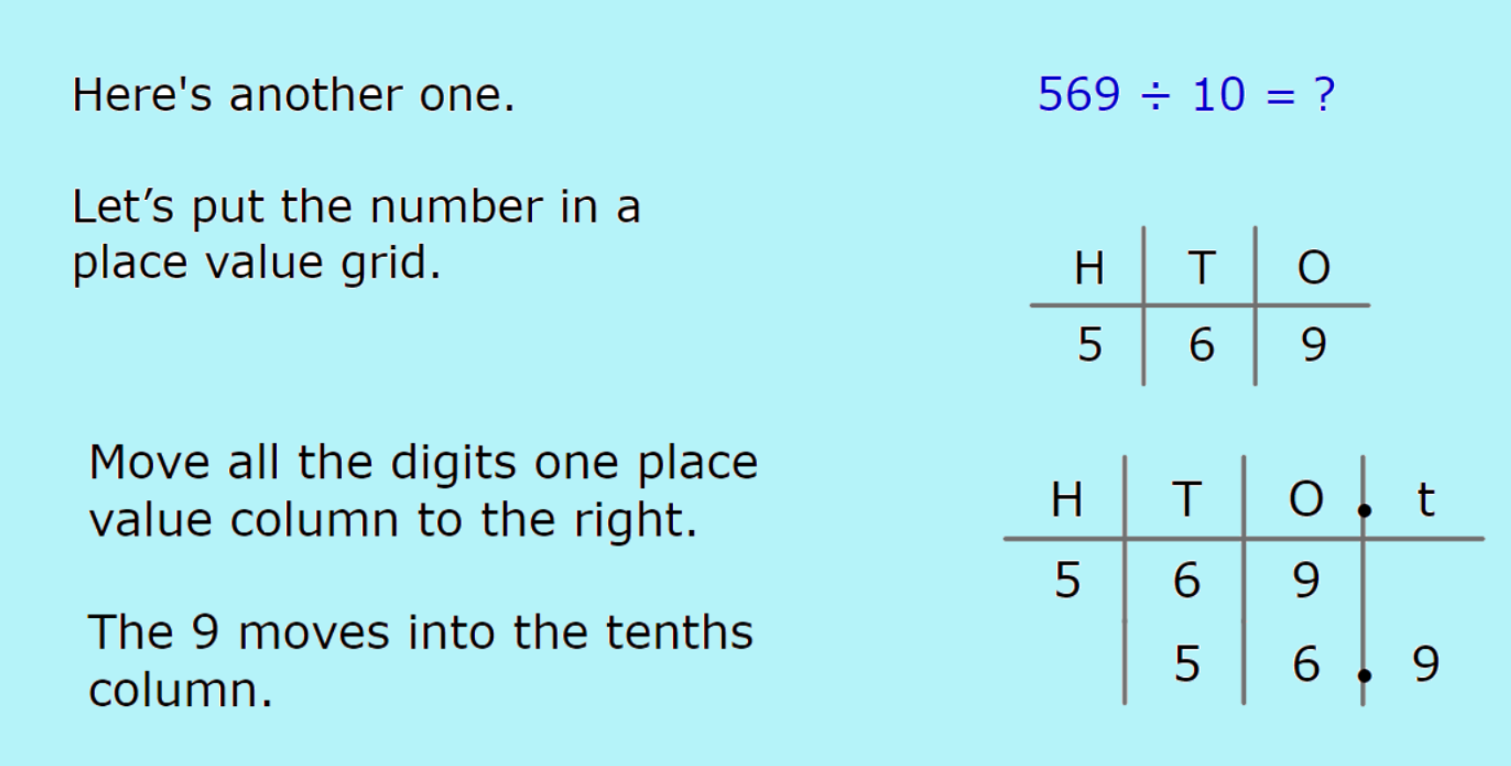
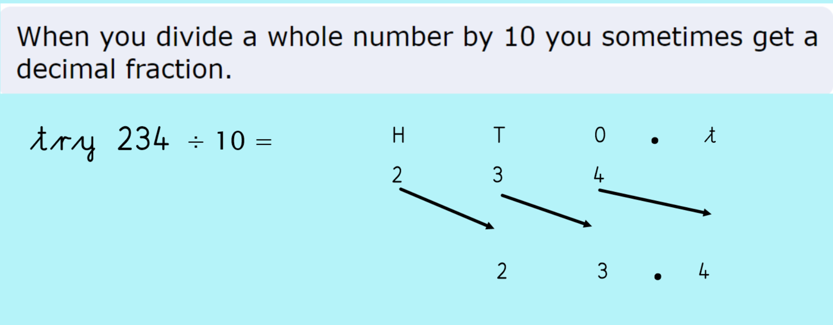
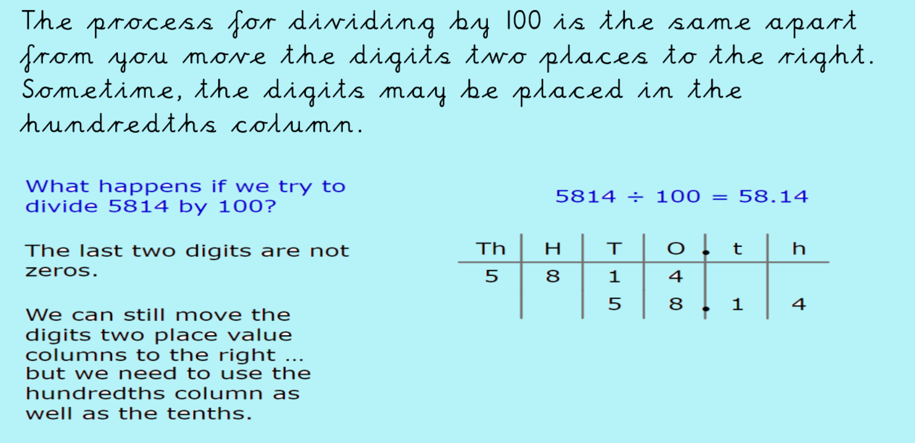
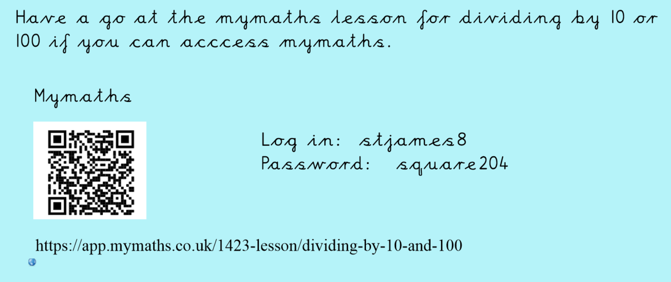
If you don’t have my maths, have a go at the worksheets provided.

