Introduction
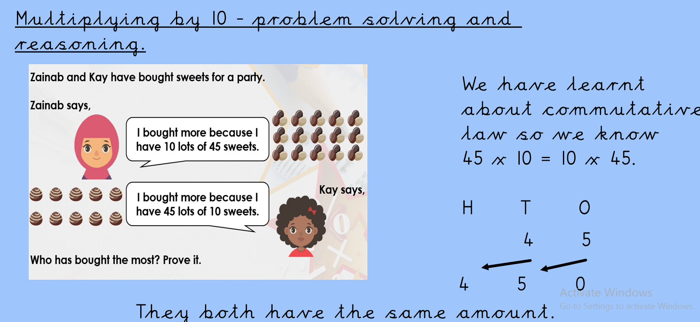
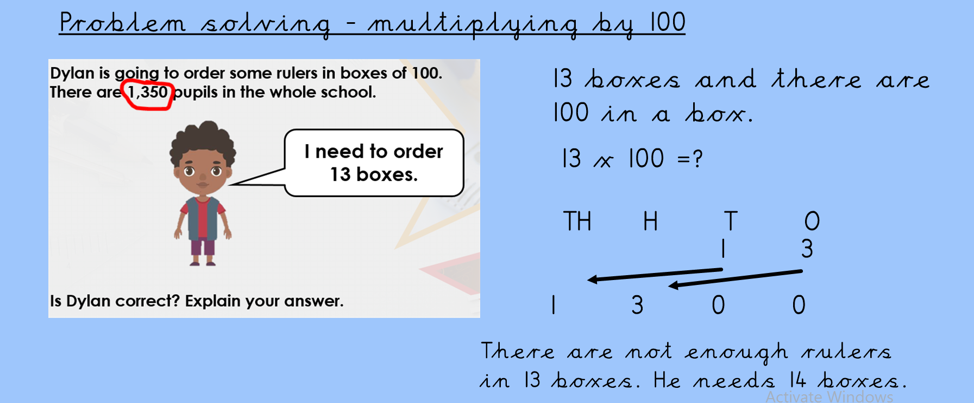
If you need an explanation for this, please ask and we can make a video to explain it or you can log in for live lesson.

