L.I:- To be able to recognise significant people in science.
I will be successful if..
- I can name different palaeontologists.
- I can say what their significance was.
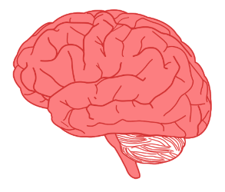
- I can say why it is important today.

What can you recall about fossils and the different types?

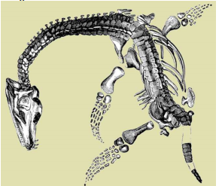

Can you draw what you think this fossil would have looked like alive?
Can you tell me 6 main facts about Mary?
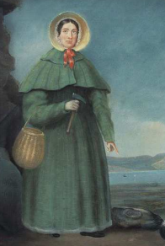
Key thoughts
Why do you think Mary’s discoveries were better after a good storm?

When Mary and Joseph discovered the skull of an Ichthyosaur – what animal do you think Mary thought it was?

What has helped Mary to become famous?
These things helped Mary to become famous | These things were against Mary becoming famous
