LI: To make simple links between promises in the story of Noah and promises that Christians at a wedding ceremony.
I will be successful if:
I can understand the term vows.
I can understand that Christian wedding ceremony makes a partnership between two people and God.
I can identify the promises people make at a wedding to each other and God.

Match these people to the promise they make.
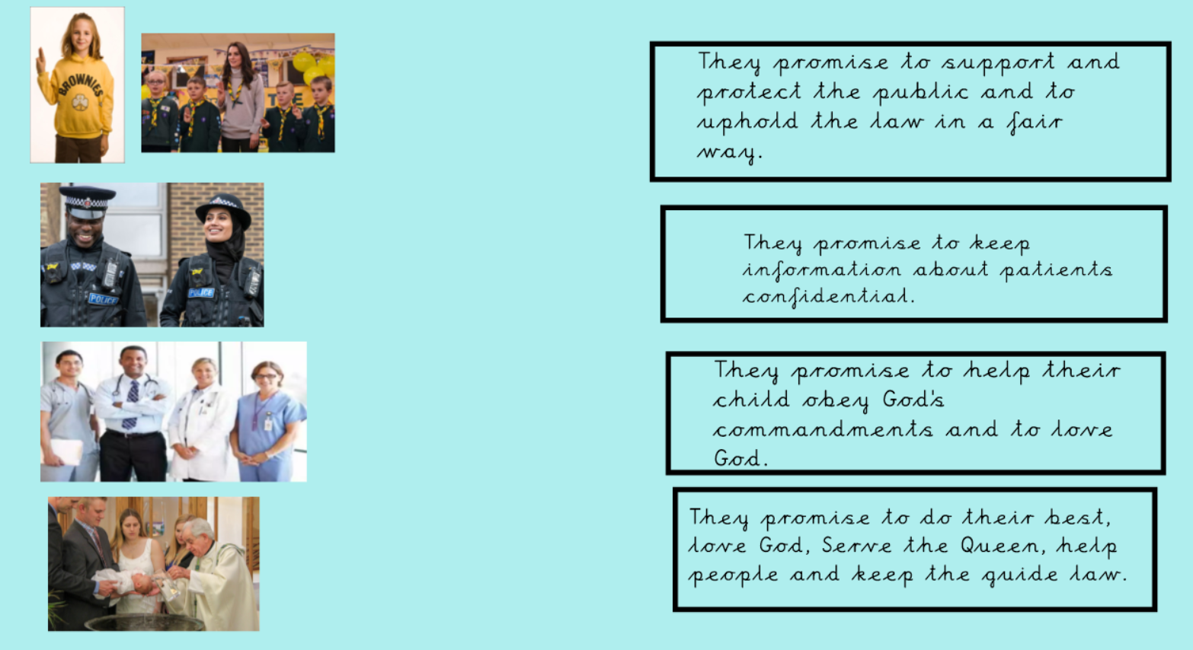

Look at the simplified version of a wedding ceremony.

Which of these promises are used in a wedding ceremony and which are made up?
See if you can find these in the wedding ceremony.

If you can, write “real” and write the name of the person who makes that promise. (Bride, Groom, family, congregation, witnesses) If they are false, write “false”.

Promise | True | False | Who might say it?
I promise to buy you flowers every week.

I promise to love her, comfort her, honour her and protect her.

I promise to remember your birthday and to buy you a present.

I promise to always help with the jobs in the house.
I promise to honour you and to give you everything I can.
I will share everything with you within the love of God.
They have declared their marriage by the joining of hands and by the giving and receiving of rings. I therefore proclaim that they are husband and wife.

I promise to be with you from this day forward, for better, for worse, for richer, for poorer, in sickness and in heath.

I promise to sing hymns to you every day.

They have declared their marriage by the joining of hands and by the giving and receiving of rings. I therefore proclaim that they are husband and wife.
When God made a promise to Noah, he sent a rainbow. 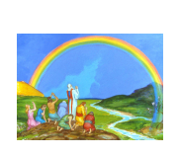

Can you draw 2 symbols are used in a wedding? What are they used for? 