Word bank
Paving stones
Layer of stones
Cement
Kerb stones
Pebbles
sand

LI: I can explain the significance of events during the Roman period
I will be successful if:
I can use key vocabulary to talk about events in History.
I can ask relevant questions.
I can continue to develop chronology

Can you label the structure of a Roman road?
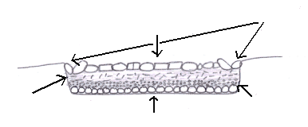
3 things about Roman Roads

