LI: To use relative clauses in my writing.
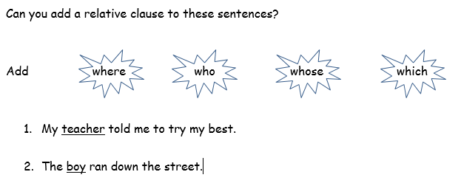
I will be successful if…
I can identify what a relative clause is
I know it follows a noun.
I know that it starts with who, which, where, when, what
I remember to trap it with 2 commas either side.
