L.I- To be able to explain the physical process, which affect coastlines.
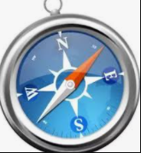
I will be successful if..
- I can explain what erosion is.
- I can name the different types of erosions.
- I can link coastline erosion to global warming.
Recap:- Why would tourists be interested in visiting Whitby?

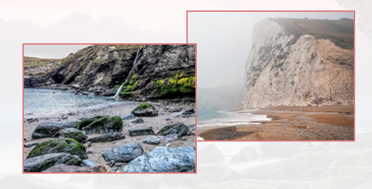
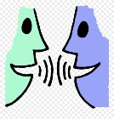What can you tell me about these images?

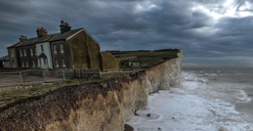
What is a coastline? Why is it important?

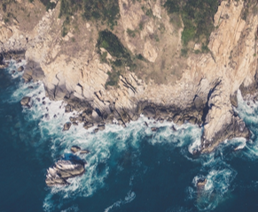
What is erosion?

Can you name and describe the 3 types of erosion?

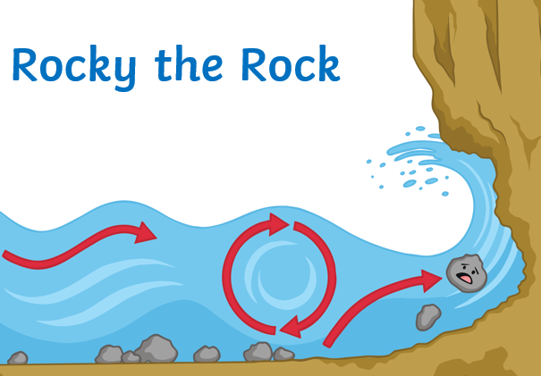
Can you explain the image using our key vocabulary?

Research
