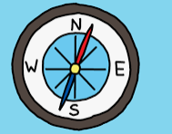
L.I:- To be able to compare and contrast different locations.
I will be successful if…
- I can locate Saltaire using maps.
- I can describe the human and physical features of Saltaire.
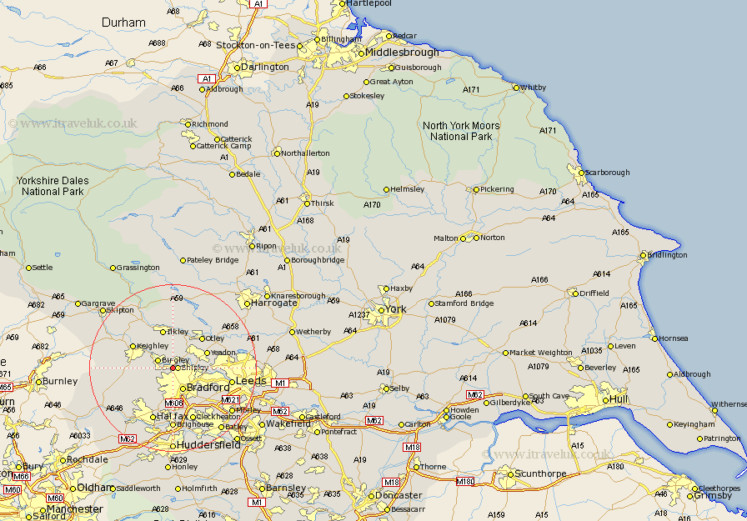
- I can compare geographical features of two locations.

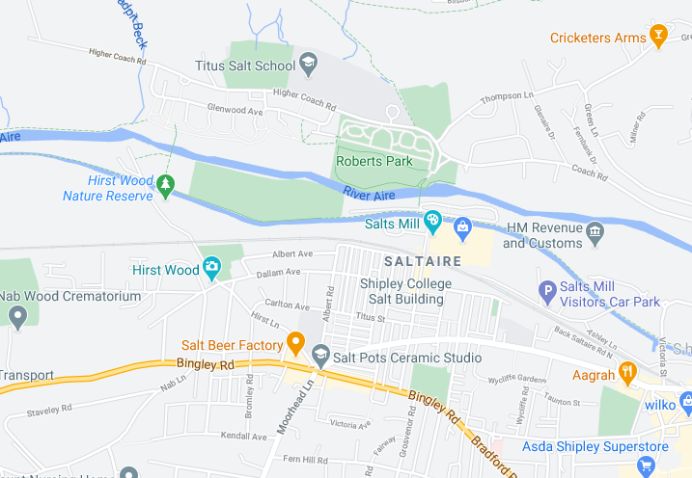
Can you locate Saltaire on the Digi maps and find its location?

Which physical feature scan you see that surrounds the village of Saltaire?

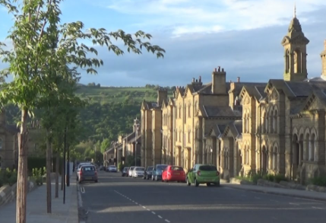
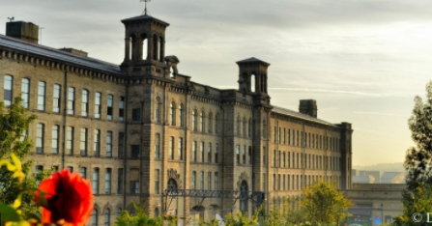
Why might people visit Saltaire?

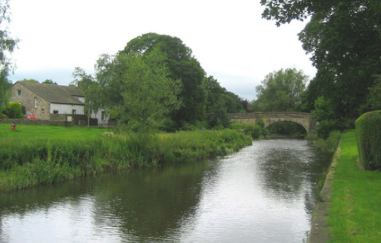
What has Saltaire got running through it? What is its name?

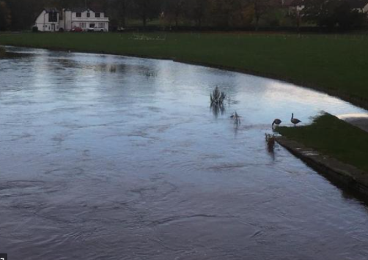
In the last few days, this has flood due to the increased amount of rainfall. Can you recap how the water cycle effects the river levels? https://www.bbc.co.uk/bitesize/topics/zkgg87h/articles/z3wpp39

Can you track the River to the coastline and how it merges with the sea?
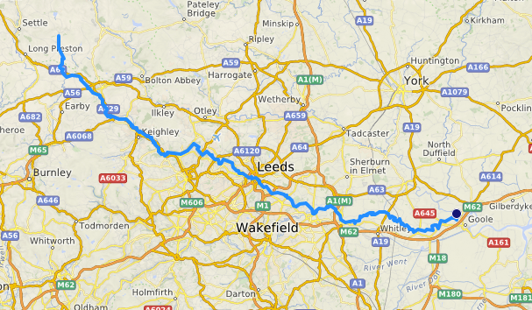

How does the water get into a river?
Water from rain, melting snow, and melting ice flows into rivers. The water in rivers always flows downhill because of gravity. Smaller streams flow into larger rivers
How long does water spend in a river?
It depends on how fast the river or stream is flowing. However, on average, a water drop spends 16 days traveling through rivers before it moves to its next journey in the water cycle.
How does it get out of the river?
Water leaves rivers when it flows into lakes and oceans. The water that is in rivers eventually flows into an ocean at a delta like the one in the picture. The river drops the sand and pebbles that it carried when it reaches a delta.
Why don’t rivers run out of water?
At the same time water is leaving a river, more water from precipitation and melting snow and ice is joining it.
