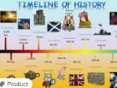
LI: To understand what Britain was like before the Industrial Revolution.

Success Criteria: | TA
I know that the UK was an agriculture economy before the IR
I can give examples of work that was undertaken.
I can produce freeze frame of the work.

Brain Dump: What was the Industrial revolution?

