LI: To find equivalent fractions using my multiplication and division knowledge.
I will be successful if…
I can recall my multiplication and division facts.
I can identify the numerator and denominator.
I know the whatever I do to the numerator, I must do to the denominator.

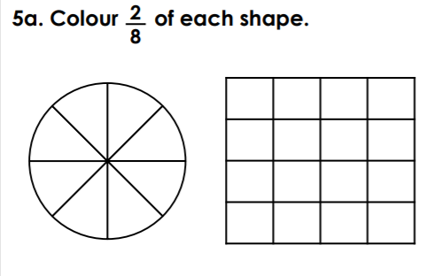
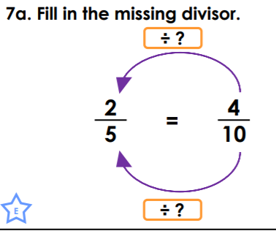
You do:

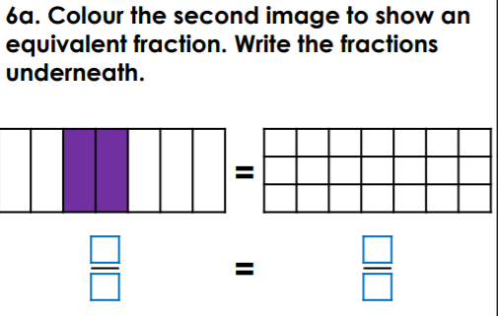

Challenge:
