Tuesday 12th January
RE
LI: To Make clear links between the story of Noah and the idea of covenant
Main Activity
Watch the following video on Youtube or read the story of Noah below.
What is Noah like as a person?
https://www.youtube.com/watch?v=_vjjhMWJ2wE
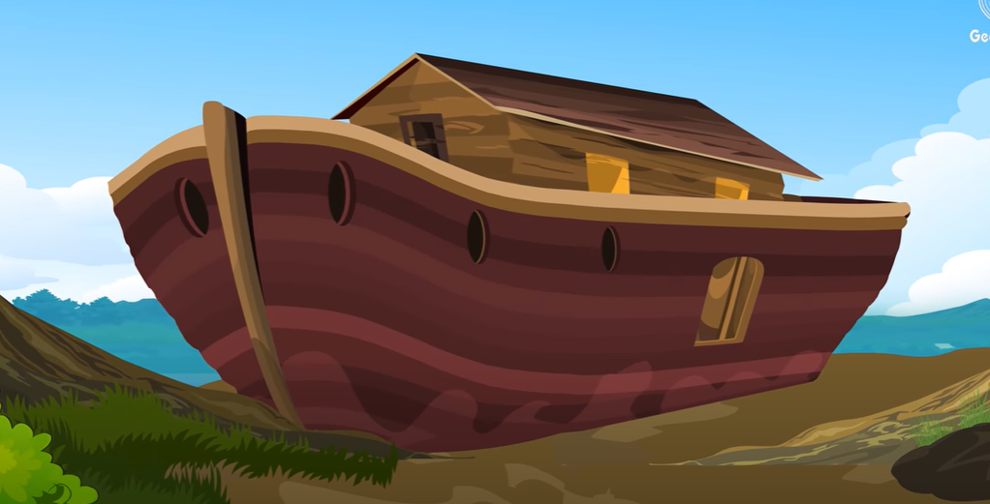
The Story of Noah

Noah's Ark
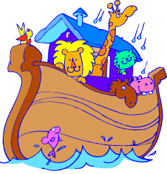
Categories: NoahDuring Noah's lifetime, people were acting very wickedly. This made God unhappy. It made Him sad because people seemed to be thinking more about themselves than about God. Noah, however, was a good man. He loved and obeyed God. And God loved Noah very much. God actually loved all the people as much as He loved Noah - but at the time, only Noah was listening to God.
God told Noah to build an ark - a big boat. So Noah followed God's plan and built a boat that was one-and-a-half football fields long. That's a huge boat! Noah's neighbors laughed at him because there wasn't any water in the desert where they lived. But God told Noah that a great flood was coming. Noah tried to warn the people to change their ways so that they could hear God too. But they wouldn't listen. They just kept on with their selfish lives.
God asked Noah to collect two of all the creatures of the earth and bring them into the ark. He also told the animals to find Noah - so it wasn't hard for Noah to gather them together. Pairs of each kind of animal were put safely inside the ark before it began to rain. Noah's wife, and his three sons, and their wives were also safe on the boat. When everyone was aboard, God shut the door.
Noah and his family and the animals lived in the ark for seven days before the first rain drops fell. Then it rained for forty days and forty nights. Soon the earth was covered with water. After it stopped raining, the water continued to rise for 150 days. The ark landed in the mountain range of Ararat during the seventh month of the flood. God sent a big wind and the waters began to evaporate. Noah and the floating zoo had to stay in the ark for several more months while the earth slowly dried out.
Finally, Noah sent a raven out of the ark's window to look for land. The raven never returned. Noah waited another week for the water level to go down and then sent a dove to do the same thing. The dove couldn't find a place to rest, so it returned to the ark. Another week passed, and then Noah sent the dove out again. This time it came back with an olive branch. Noah now knew that the water was low enough for a tree branch to show! When Noah sent off the dove a week later, it didn't return. The dove had found a place to live - on dry land.
Altogether, Noah and his family and the animals lived on the ark for 1 year, 1 month, and 27 days!
It was now time for all the creatures and Noah's family to move off the ark. Noah and his family and the animals needed to start life over again. After everyone left the ark, Noah prayed to God to thank Him for keeping them safe. Suddenly a bright rainbow filled the sky. This was God's promise that He would never flood the earth again.

Role on the Wall: Noah
Inside- write words to describe his character.
Outside- add quotes from the story to support your views

