The Problem
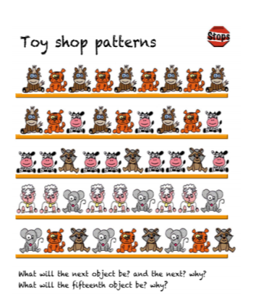
Find the pattern to help you work out this problem. Remember to show how you worked it out.

