LI: To solve a problem using a table or list.
I will be successful if…
I can retrieve key information from a question to help me.
I can record information clearly on a table
I can work systematically to solve a problem.
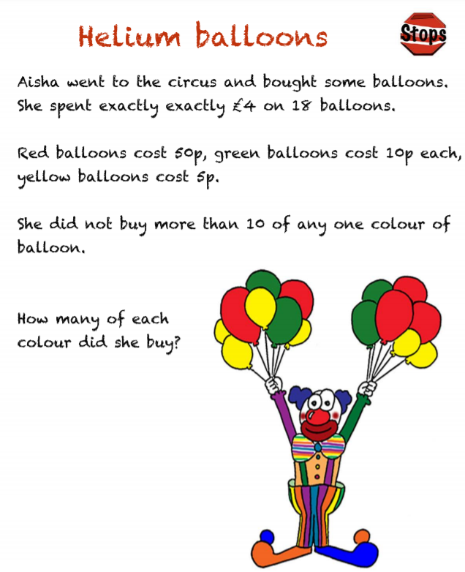
Step 1)

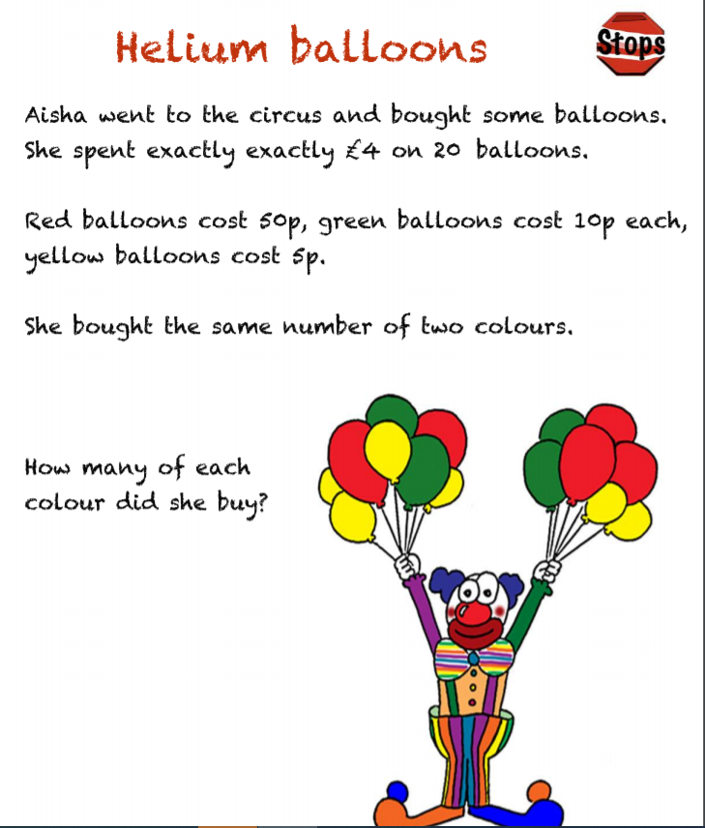

Step 2)

Step 3)

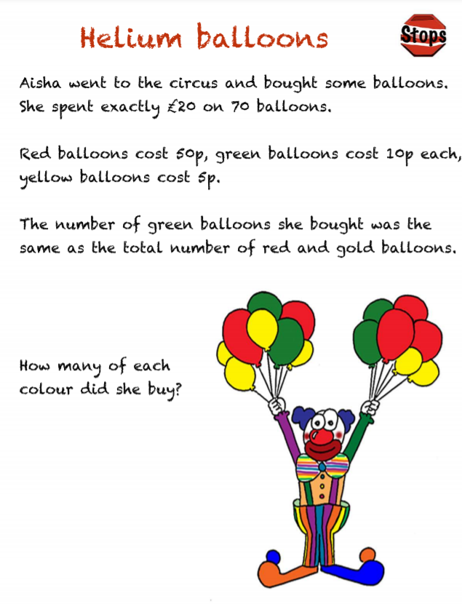
Challenge)

