Tuesday 12th January
RE
Memory Recall Quiz
Complete this quiz about our learning in RE from last term.
1. Which religion did we learn about, other than Christianity?
(a) Sikhism
(b) Islam
(c) Hinduism

2. What do you call the festival of light celebrated by Hindu people?
(a) Rama
(b) Diwali
(c) Shiva

3. What is the name of this Hindu God? 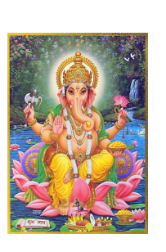
(a) Guru
(b) Ganesh
(c) God

4. Why did Ganesh have a small mouth but big ears?
(a) To talk less and listen more
(b) Because he looked like an elephant
(C) To stop him over eating

