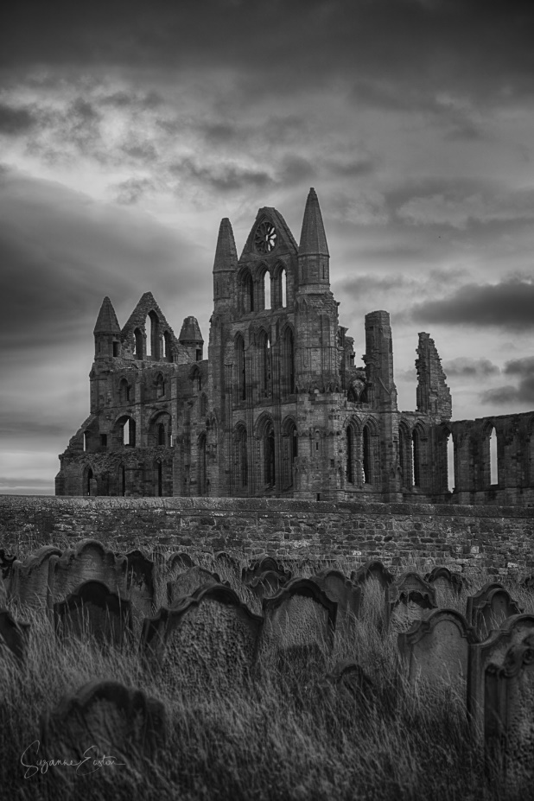
Write a paragraph about the image of Whitby Abbey using the following features.
How many points can you earn?
Apostrophe for contraction (2pts) | Apostrophe for possession (3pts) | Relative clause (4pts)
Subordinate conjunction (2pts) | Colon (3pts) | Semi-colon (4pts)
Modal verbs (2pts) | Correctly punctuated direct speech (3pts) | Punctuation for parenthesis (4pts)

