Monday 11th January 2020
1e predict what might happen on the basis of what has been read so far.
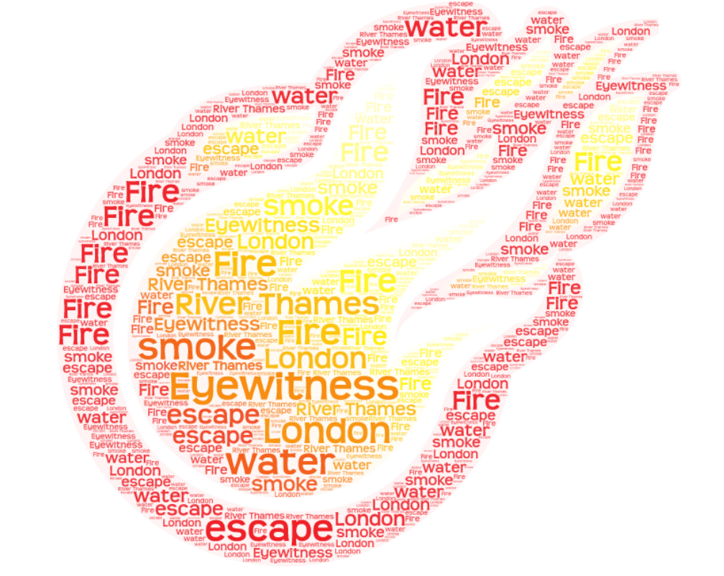

I predict that….
I think that….
________________________________________________________________________________________________________________________________________________________________________________________________________________________________________________________________________________________________________________________________________________________________________________________________________________________________________________________________________________________________________________________________________________________________________________________________________________________________________________________________________________________________________________________________________________________________________________________________

