Monday 11th January 2020
1e predict what might happen on the basis of what has been read so far
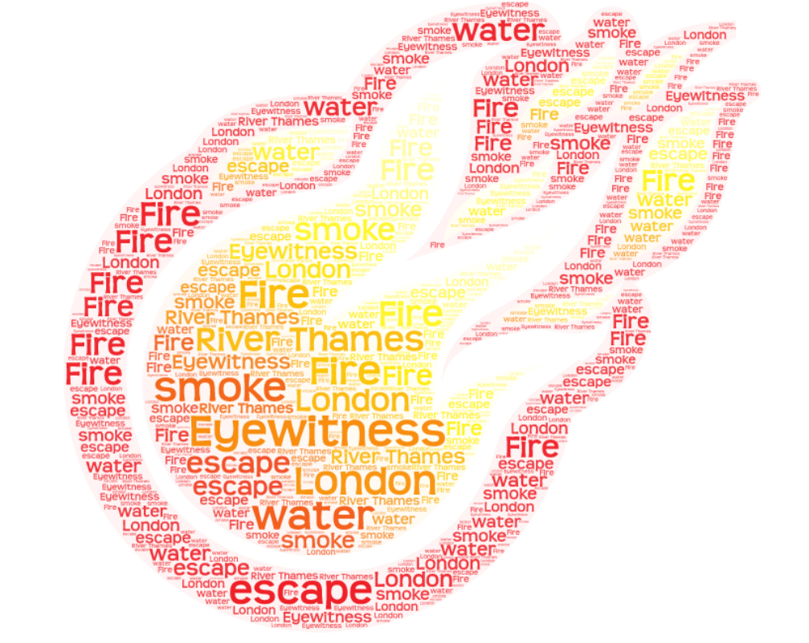

I predict that….
I believe that…
After speaking to my partner, I believe that…
________________________________________________________________________________________________________________________________________________________________________________________________________________________________________________________________________________________________________________________________________________________________________________________________________________________________________________________________________________________________________________________________________________________________________________________________________________________________________________________________________________________________________________________________________________________________________________________________

