Monday 1st February
Li: to be able to use and identify fronted adverbials
I will be successful if:
- I can explain where a fronted adverbial belongs in a sentence
- I can use a variety of fronted adverbials
- I can use a comma to separate a fronted adverbial from the main clause
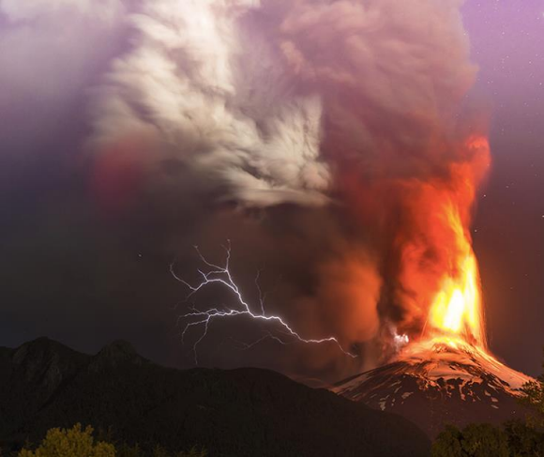
Match the fronted adverbial to the correct clause.
Unexpectedly,
All of a sudden,
In the distance,
Lava went over the ground.
Lightning lit up the sky.
Thunder rumbled loudly.

Missing commas- add in the missing commas to show the fronted adverbials.
- Nervously Lucas watched Vesuvius erupt.
- With a loud roar Vesuvius blew its rocky top.
- Beneath the crashing waves the fish rapidly searched for shelter.
- Completely exhausted Lucas stopped rowing and stared at Pompeii.
Adverbial Sort- sort the different types of fronted adverbials into the correct column
Slowly | Above the clouds | After a while | Unexpectedly
In the distance | All of a sudden | Outside | Eventually
Immediately | Unfortunately | Without warning | Under the ground

Manner- how | Time - when | Place – where

Compete the sentences- finish the sentence with an appropriate fronted adverbial
__________________________, the citizens of Pompeii began to cry.
__________________________, Lucas untied his boat.
__________________________, Vesuvius watched over Pompeii.
__________________________, the birds soared swiftly.
__________________________, tremors shook the ground.
__________________________, ash shot up into the sky.
Sentence challenge: write your own sentences describing the image. Start with a fronted adverbial and remember to use a comma to separate it from the rest of the sentence.
__________________________________________________________________________________________________________________________________________________________________________________________________________________________________________________________________________________________________________________________________________________________________________________________________________________________________________________________________________________________________________________________________________________________________________________________________________________________________________________________________________________________________________________________________________________________________________________________________________________________________________________________

