Monday 1st February
LI: to be able to use and identify verbs and adverbs
I will be successful if:
- I can explain what a verb is
- I can explain what an adverb is
- I can identify verbs and adverbs
- I can use them in a sentence
Define the word
What is a verb? ___________________________________________________
What is an adverb? ________________________________________________
Sort the words into the correct column
Loudly | Sail | Strongly | Flow
Swim | Sadly | Explode | Dangerously
Run | Crash | Rapidly | Silently

Verb | Adverb

Choose the correct word
- Lucas fell down and hurt his leg _______________.
- “We have to go now!” Lucas shouted _____________.
- When the volcano erupted people ran _______________.
- The lava flowed down the mountain ________________.
bad | quickly | loudly | rapidly
dangerously | badly | whisper | awful

- Lucas rapidly _____________ towards his boat.
- The lava ___________________ down the mountain.
- Ash _________________ into the air.
- The boat __________________ dangerously in the water.
loudly | floated | flowed | swam
rocked | ran | jump | shot

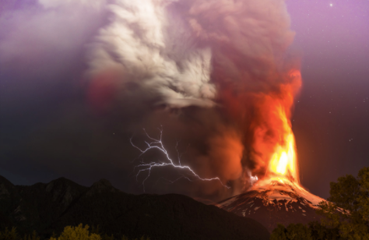
Create a list of verbs and adverbs to describe the volcano.
Verbs | Adverbs

Sentence Creator: write sentences about the volcano using verbs and adverbs.
__________________________________________________________________________________________________________________________________________________________________________________________________________________________________________________________________________________________________________________________________________________________________________________________________________________________________________________________________________________________________________________________________________________________________________________________________________________________________________________________________________________________________________________________________________________________________________________________________________________________________________________________

