Monday 25th January 2021
Content Domain: 1b identify / explain key aspects of non-fiction texts, such as information Read page 16-17 for more help.

- What year did the fire start?
Tick one

2020 1754

- 1666

- What did people use to put out the fire in 1666?
Tick one

Plastic buckets Wooden buckets

Leather buckets Hand squirts

- What did Pepys do when the fire took place?

Went to warn the king Went for a party

Went for a boat ride Did nothing

- Was it safe to put out the fire in 1666? Explain your answer. Write the answer in your books.

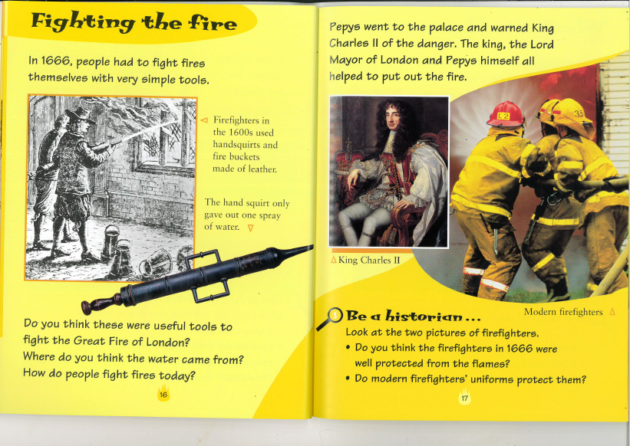
- Do you think the hand squirt was a useful tool to put out the fire in 1666? Write the answer in your books.

