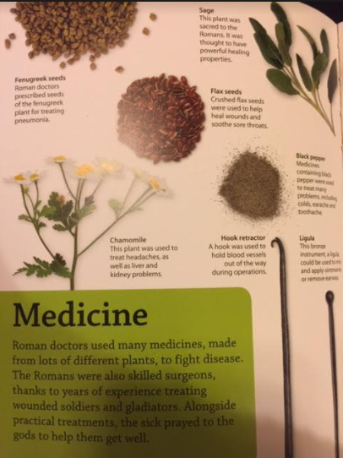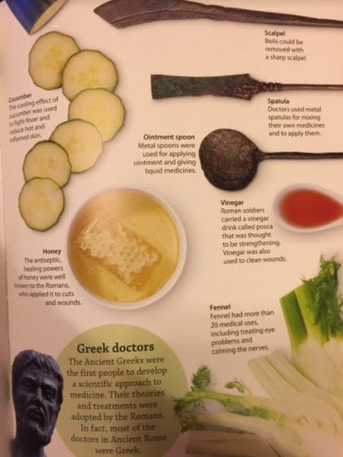
Monday 25th January
Roman Medicine
Read the text and match the medicine to its use.
Honey
Cucumber
Vinegar
Chamomile
Sage
Black pepper
Fennel
Flax seeds
Fenugreek seeds
Treated eye problems and calmed the nerves.
Used to clean wounds. Was thought to be strengthening.
Treating pneumonia.
Used for cuts and wounds.
Powerful healing properties.
Heal wounds and soothe sore throats.
Fight fever and reduce hot skin.
Treated headaches as well as kidney and liver problems.
Treated colds, earache and toothache.

Read the text and explain what each medical tool was used for.
Hook retractor
Ligula
Ointment spoon
Spatula
Scalpel

Read the box labelled ‘Medicine’
Find and copy one word which suggests that the Roman surgeons were good at their job. _________________________________
Who did the Roman surgeon’s practice on? ___________________________________________________________________
What else did the Roman’s do to help them get better? _________________________________________________________

