Co-ordinating and Subordinating Conjunction Bingo
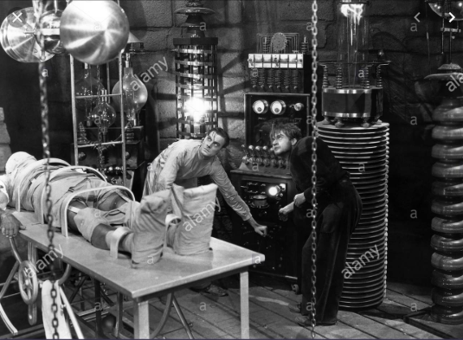

and | for | but | because | whilst | as
so | yet | or | after | until | since

Read the Frankenstein WAGOLL - L.I.: to be able to identify grammar features within a text
I will be successful if:
- I can explain what the grammar is
- I can find examples of the feature within the text
Grammar Grid
Year 6 Writing Expectation | My Example | Does Miss Spivey agree?
Co-ordinating Conjunction Sentence

Subordinate Conjunction Sentence

Fronted Adverbial

Expanded Noun Phrase

Prepositional Phrase

Modal Verb

Speech

Adverb for time

Adverb for detail

Relative Clause

Semi colon ;

Colon :

Dash -

Frankenstein
N1: I must write the events down, immediately, just as they happened. How strange they are; I bet most people would think me consumed with madness.
We’d become trapped in the Arctic ice, in thick, blanketing fog. The ship was dangerously hemmed in on every side, and there was little sea left to float on. Mountains of ice threatened to crush or trap us here forever, where we would surely die of cold and starvation.
When the fog had been swept aside, all the crew and I could see was nothing but vast, rugged plains and peaks of ice without end. On the horizon, stood the shape of a man. But not just any man - a huge, monstrous man of gigantic size. The strange figure was guiding his sledge across the ice, speeding hastily towards the north. I watched - perplexed and still - until I could see him no longer.
Suddenly, there was thunderous, ear-splitting roar! The ice, which had ensnared the ship, finally broke up and the once ice-bound ship was able to move freely once more. Dawn broke over the icy wasteland; I could hear a low whimper coming from the sea. To my utter astonishment, it was another sledge, marooned on a quickly diminishing fragment of ice. The man (nearly frozen to death) was skeleton-thin from exhaustion and suffering. Once safely on-board, this man, who had madness barely contained within his blood-shot eyes, told me his horrifying story. A story so unbelievable, that if I had not heard it first-hand I would not have believed it myself. I asked him, why he had come so far on the ice, alone. His face became darkly gloomy and a black despair descended upon him, “I have come to find the one who has fled from me.” And so began his extraordinary and tragic tale.
N2: You see, Captain Walton (he said) I once had a dream. I dreamt I’d use my scientific knowledge and skill to create an entirely new kind of being, one that would never suffer illness or death. I believed this journey of mine into the unexplored reaches of science would bring great and wonderful things to mankind…how foolish I was.
I dreamt I’d become famous, rich and respected for the great gift I had given the world. My name is Victor Frankenstein. I had heard of men, who’d made major scientific discoveries and had peered into the hidden depths of nature. How I longed to be one of these men! I was soon aflame with one singular thought, one idea, one purpose. I wanted to go further, be greater than all before. I would create life itself!
I spent days, night, months, years, studying life and death, until I could make life. I made dead matter become alive again. What an astonishing power I held in my hands! I went to graveyards, mortuaries and hospitals gathering (in the dead of night) all the matter I would need. I lost all idea of the outer world, so consumed with my task I became. I didn’t eat or sleep. I soon became pale and thin, but my ambition was enough to drive me forward. A year passed, until I had completed my challenge. In my laboratory, I had formed a completely new being, out of dead matter.
It was a dreary night in November with rain pattering dismally against the panes. I collected the scientific instruments for giving life around me. The lifeless thing I’d created lay at my feet. Now to send the electric spark into it, and bring it alive. It was one o’clock in the morning - my candle nearly burnt out - before the glimmer of its failing light showed me the dull yellow eyes of the creature open for the first time. It breathed hard. A great jerk and shudder shook its vast limbs.
I stared in utter horror; with such care and patience I’d tried to create this being! Every part of him fitted his great size. I’d chosen his features in the hope they’d be beautiful. Beautiful!? His muscles and veins were barely covered by his yellow skin. His hair was shiny black and flowing. His teeth were pearly white.
But all was only the more horrible against his watery yellow eyes, his shrivelled skin, his straight black lips. An Egyptian mummy brought to life wouldn’t be as hideous as that Thing. I’d gazed on him when he was unfinished, and he was ugly then. But when those muscles and joints were able to move, he became… a Thing of Nightmares.
The beauty of the dream that had filled my life for two years evaporated. Only shock and disgust tortured me. It was a grotesque, unnatural thing that lay before me. I couldn’t look at it.
I fled from the laboratory.
N1: Here Frankenstein could say no-more as he fell into a deep and troubled sleep. I later found out that Frankenstein had turned his back on his creation, abandoning him. The Creature had fled to dark and faraway places. Frankenstein had made a solemn vow to destroy the creature; he vowed to chase it down and kill it. For weeks, he had pursued the creature until he could carry on no more. This is when I discovered him, adrift on an ice floe. Slowly, Frankenstein passed away; his health slipping from him until he took his final breath. As I gazed out of the frost covered window, I saw a shadow moving upon the ice’s surface. The shadow resembled a man, a giant man. I watched him swept away by the waves, to be lost in endless darkness and distance.
LI: To retrieve information from the text.
I can find key information in the text.
I can skim, scan and trap information,
I can explain my answers, using the evidence in the text.

Using the WAGOLL, label the image below with the features, which are accurate to the description.
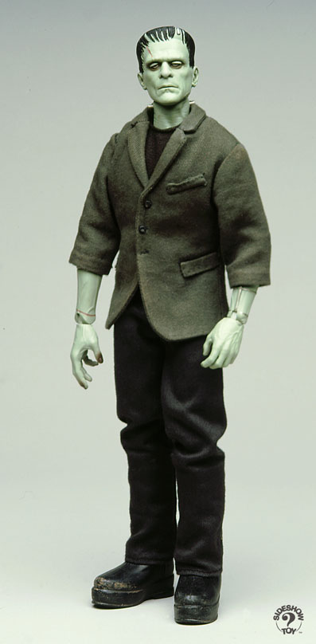
Every part of him fitted his great size. I’d chosen his features in the hope they’d be beautiful. Beautiful!? His muscles and veins were barely covered by his yellow skin. His hair was shiny black and flowing. His teeth were pearly white.
But all was only the more horrible against his watery yellow eyes, his shrivelled skin, his straight black lips. An Egyptian mummy brought to life wouldn’t be as hideous as that Thing. I’d gazed on him when he was unfinished, and he was ugly then. But when those muscles and joints were able to move, he became… a Thing of Nightmares.
Now, identify and explain which of the Creature’s features are incorrect (or not shown) in the image.
Feature | Evidence the image is wrong

Find and copy the adverb that tells us Captain Walton wrote his account straight away.
____________________________________________________________________

Read paragraph 3. Find and copy the phrase, which suggests it was early morning.

__________________________________________________________________________

