Instructions: Lesson 1
As part of our teaching unit we do a ‘cold’ writing task at the start and a ‘hot’ writing task at the end. These two pieces of writing are used to track and assess children’s progress with their writing.
The ‘cold’ task comes at the start as we want to see what the children are capable of before we teach them the specific objectives. In a ‘cold’ task the children are given a story structure and a story outline and it is up to them to turn it into a fully written story. They should try to include their Year Groups grammar expectations. E.g. expanded noun phrases.
The ‘hot’ task comes at the end of the unit and we use it to see what the children have learnt over the teaching unit. In the ‘hot’ task children are given the story structure which we have been looking at in the unit and asked to ‘invent’ their own story which fits the story structure. The children should also try and include their Year Groups grammar expectations.
Here are the grammar expectations for each Year Group:
Year 2.
- Capital letters and full stops
- Coordinating conjunctions (or, and, but) and subordinating conjunctions (when, if, that, because)
- Expanded noun phrases (2 adjectives to describe a noun)
- Question and exclamation marks
Year 3:
- Capital letters and full stops
- Coordinating conjunctions (or, and, but) and subordinating conjunctions (when, if, that, because)
- Expanded noun phrases (2 adjectives to describe a noun)
- Question and exclamation marks
- Adverbs to express time (e.g. suddenly)
- Prepositions to express (after, before) and place (next to, above, below, beneath)
- Dialogue using inverted commas
Year 4:
- Capital letters and full stops
- Coordinating conjunctions (or, and, but) and subordinating conjunctions (when, if, that, because)
- Expanded noun phrases (2 adjectives to describe a noun)
- Question and exclamation marks
- Adverbs to express time (e.g. suddenly)
- Prepositions to express (after, before) and place (next to, above, below, beneath)
- Dialogue using inverted commas
- Adverbs for detail (e.g. quickly, silently)
- Fronted adverbials followed by a comma (e.g. All of a sudden, without out warning)

Li: to be able to write a rags to riches story (cold write)
Rags to Riches Story
Story structure | Action
Opening | Introduce the main character
Build Up | Main character is treated poorly
Problem | Main character gets into trouble because of their situation
Resolution | Main character overcomes his difficulties
Ending | Main character is happy.

Turn this story outline into a fully written story. Use the detail and images given to help you.
Story structure | Action | Detail | Images
Opening | Introduce the main character | Oliver Twist is born and lives in a workhouse. | 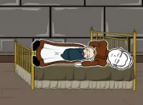
Build Up | Main character is treated poorly | Oliver works all day and sleeps on the floor. He wears rags and is hungry. Oliver gets kicked out of the workhouse because he asks for some more food. He goes to live on the streets. | 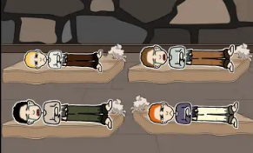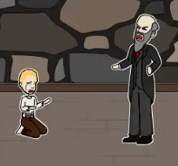
Problem | Main character gets into trouble because of their situation | Whilst living on the street he meets another homeless boy who takes him to his shelter. There Oliver meets a man who makes him steal so he can get food. Oliver gets caught stealing and is put in prison. | 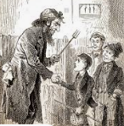  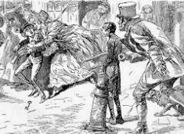
Resolution | Main character overcomes his difficulties | Mr Brownlow see Oliver at the prison. He feels sorry for Oliver and decides to take him home and look after him. | 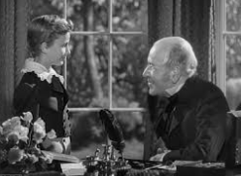
Ending | Main character is happy. | Oliver gets clean clothes and is treated nicely. Oliver gets adopted by Mr Brownlow and lives in his house and gets to go to school. | 