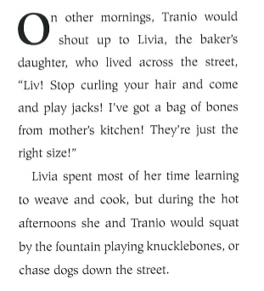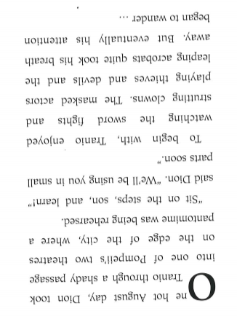
Read the text above.
Answer the questions below.
- Why did Tranio shout up to Livia?
Tick one.
He was rude
He wanted to be heard
He didn’t like Livia
He was angry with her.

- Livia spent most of her time learning to weave and cook.
What does this sentence tell you about Livia?
Tick one.
She had a job
She didn’t go to school
She was bored

- Dion took Tranio through a shady passage
Which word is closest in meaning to shady?
Tick one.
Dim
Narrow
Bright
Suspicious

- But eventually his attention began to wander
What does this phrase mean?
Tick one.
Tranio fell asleep
Tranio stopped paying attention
Tranio joined n
Tranio left

- Read the last paragraph beginning ‘To begin with,’
Find and copy two things which Tranio liked about the pantomime
___________________________________
___________________________________

- Order the boxes from 1-4 to retell the story
Tranio watched the pantomime
Tranio enjoyed watching the actors
Tranio played with Livia
Tranio got bored

