L.I:- To be able to read and interpret timetables.
I will be successful if..
- I can recall the problem solving strategies.
- I can read and annotate the information.
- I can add and subtract mentally.
- I can explain my answers.
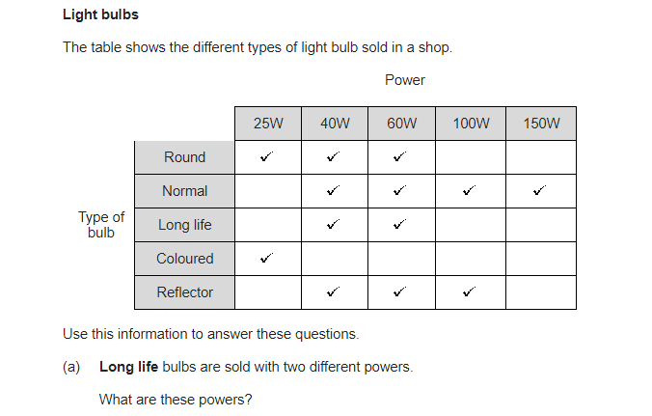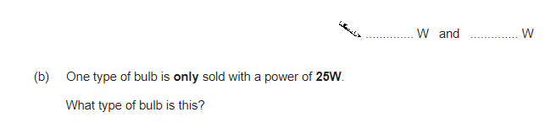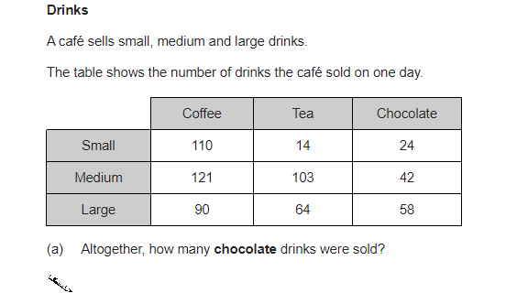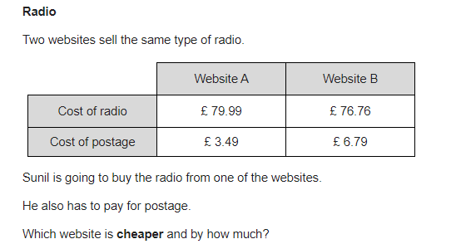

Use the PDF table to help with the data in this question.
What did the various school children find out?
These seven schools were all from very different areas of the UK. Does that surprise you? How might that have affected the data?
What differences do you notice in the ways that the data is displayed?
Which survey do you think is presented in the best way? Why?

