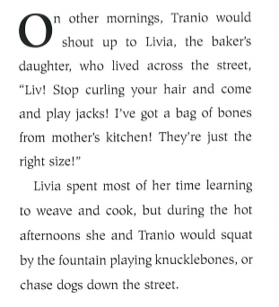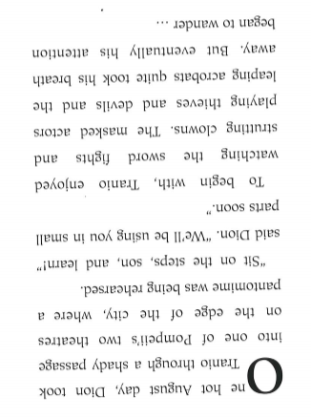

Read the text above.
Complete the grid below.
What I know
Write down facts which you can retrieve from the text.
What I think
Write down inferences using clues from the text
What I predict
Write down what you think will happen

