LI: To find the equivalent fractions of shapes and objects.
I will be successful if…
I can find the fraction of an object.
I know that equivalent means the same in value.
I can use my multiplication/divisional facts to help me find the answer.
I know the denominator and numerator needs to be multiplied of divided by the same number.
You do…
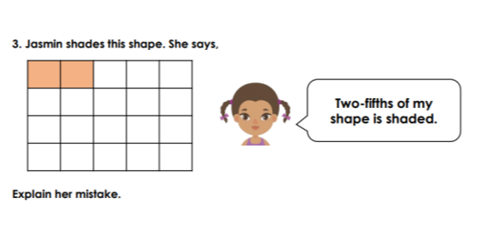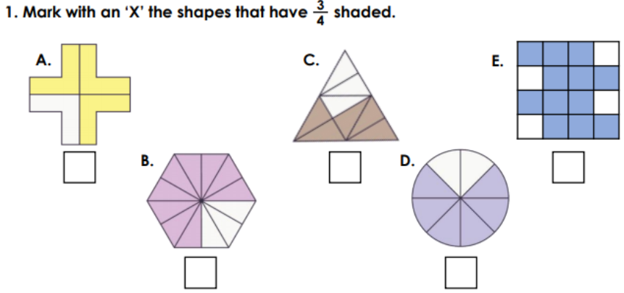

Challenge…
Start at Clare 3/7. Find a route through the maze. Clare can go up, down, or diagonally to an equivalent fraction.
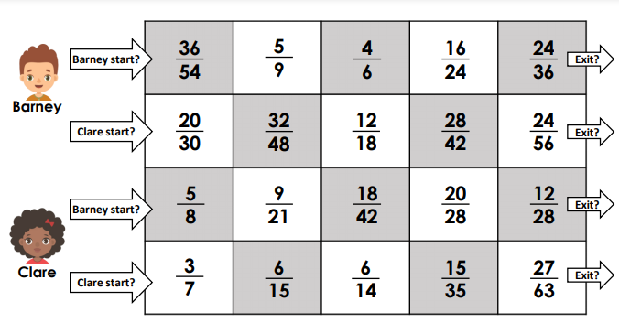
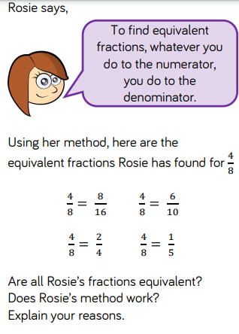
Challenge…

