LI: To divide by 10 using a place value grid and use the inverse multiplication to find related facts.
I will be successful if:
I can draw a place value grid and write the digits in the correct columns.
I can move everything one place to the right and take off a zero.
I can start with the answer and multiply by 10 using the place value grid and moving everything one place to the left.

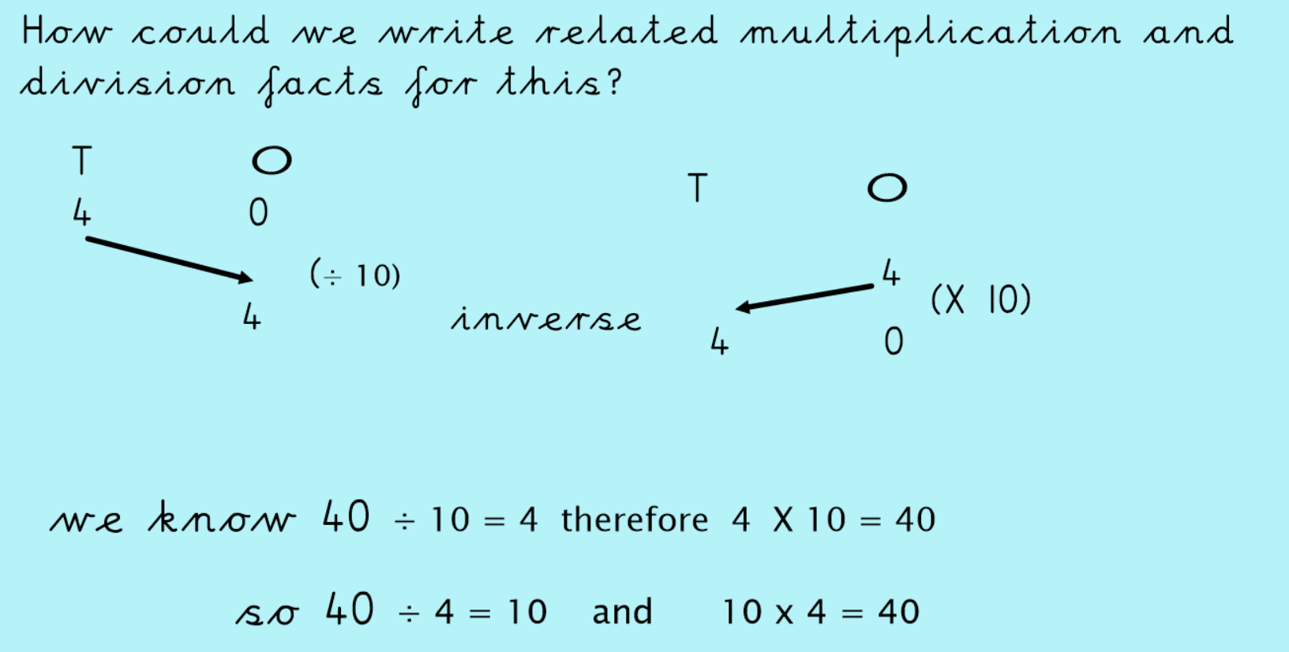
Use the model above to help you write the 4 multiplication and division facts for the following questions. Use a place value grid to help you.
1. 50 ÷ 10 =

2. 80 ÷ 10 =

3. 120 ÷ 10 =
4. 160 ÷ 10 =

5. 270 ÷ 10 =

6. 340 ÷ 10 =

Challenge
Check the fact families. Which ones are true and which are false? Prove it by using a place value grid.

1. 20 ÷ 10 = 2 20 ÷ 2 = 10 10 X 2 = 20 2 X 10 = 20

2. 190 ÷ 10 = 91 190 ÷ 91 = 10 10 X 91 = 190 91 x 10 = 190

3. 150 ÷ 10 = 15 150 ÷ 15 = 10 10 X 15 = 150 15 X 10 = 150

