PSHE Week 2 – Keeping safe, managing behaviour and risk
Task One
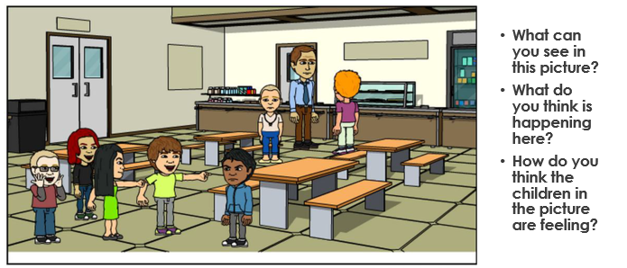

Write your answers in the box below:

Task Two: Read the information below.
What Is Bullying?
Bullying is something that can hurt you on the inside or on the outside. It hurts you on the outside by hitting you and hurting you physically. It hurts you on the inside by name calling, skitting or hurting your feelings.
Bullying is done on purpose, it’s not an accident. If someone hurts you during a game by accident that is not bullying, but if every time you played a game they hurt you, or your feelings that would be bullying.
It can aim to hurt a group of people or just one person and can be done by a group or just one person.
Bullying happens more than once. The bully/bullies do it over and over and over again and they can take away your self esteem and confidence.

Task Three
Take this quiz about bullying and let us know your score!
https://www.educationquizzes.com/ks1/personal-social-and-health-education/bullying/

(If you don’t have access to the internet, you can find the quiz below.)

Task Four
Create a poster to show the difference between falling out and bullying.

Task Five
Finish this sentence.

Bullying is unacceptable because…

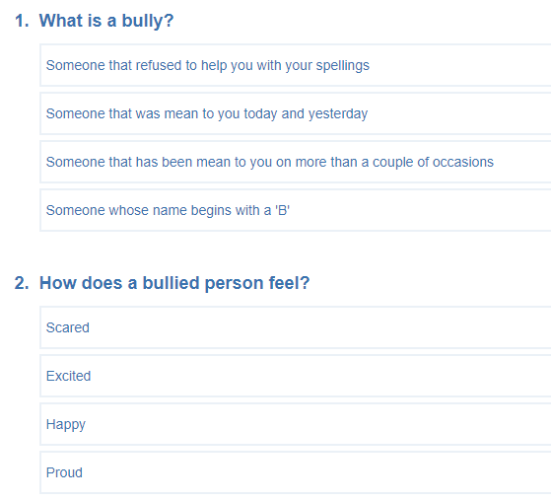

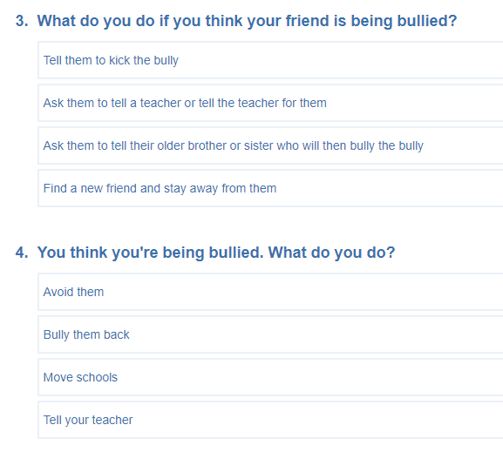

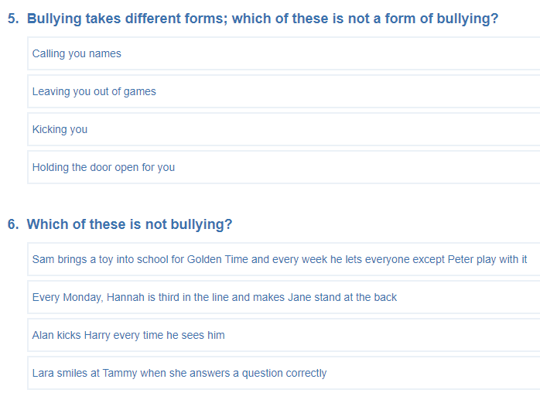

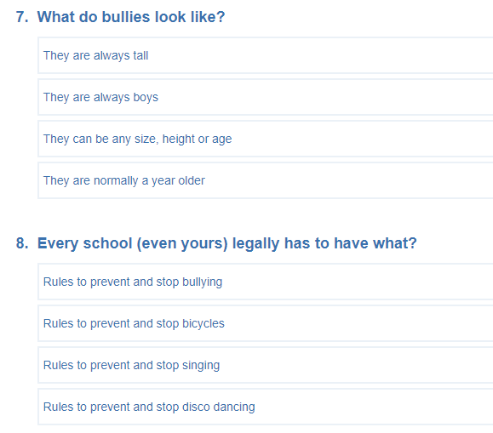

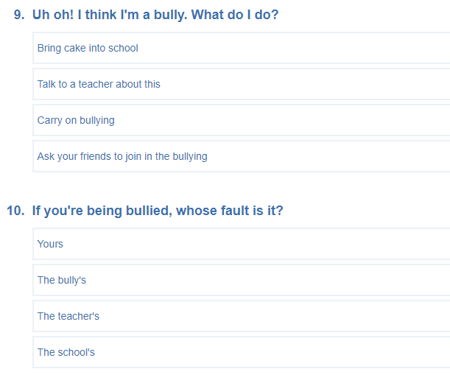

ANSWERS
1.) c
2.) a
3.) b
4.) d
5.) d
6.) d
7.) c
8.) a
9.) b
10.) b

