Phonics
Lost
Prediction – can you answer these questions to predict what will happen?
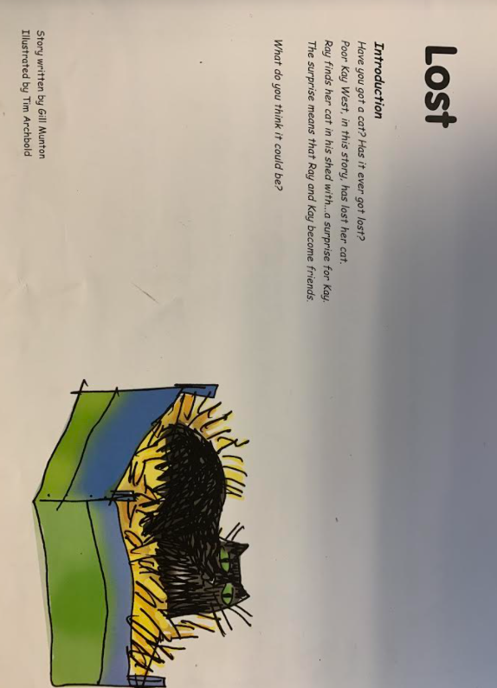

Now read these key story words – do you know what each word means?
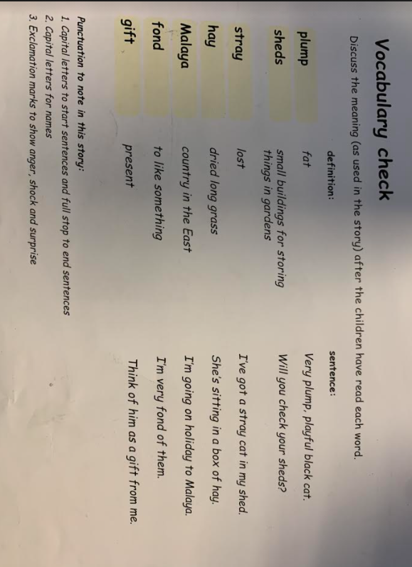

Can we read the red words?
