Phonics – 13.01.20
Lost
Read the speed sounds and green words
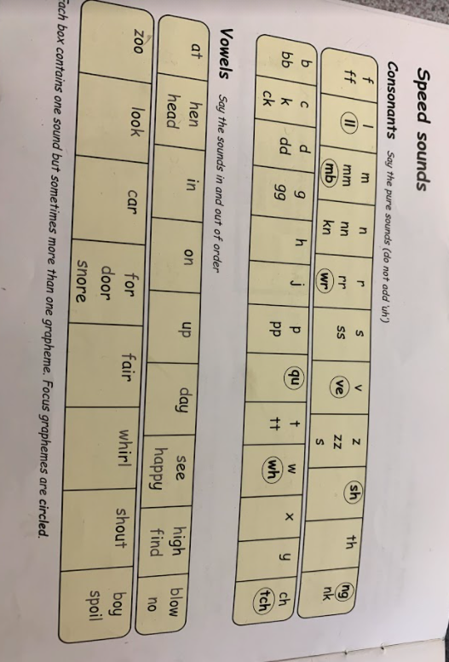

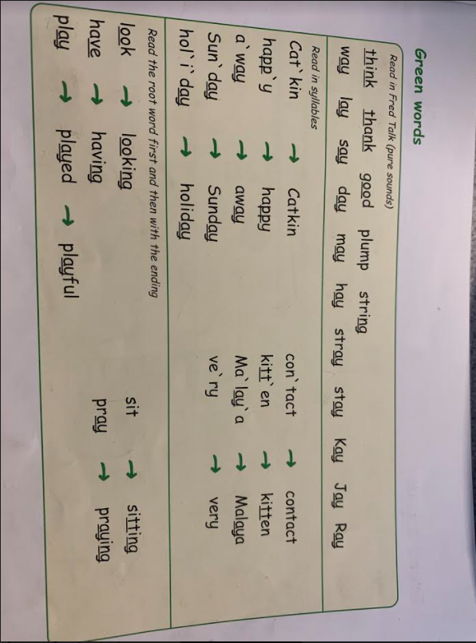

Now can you read the text?

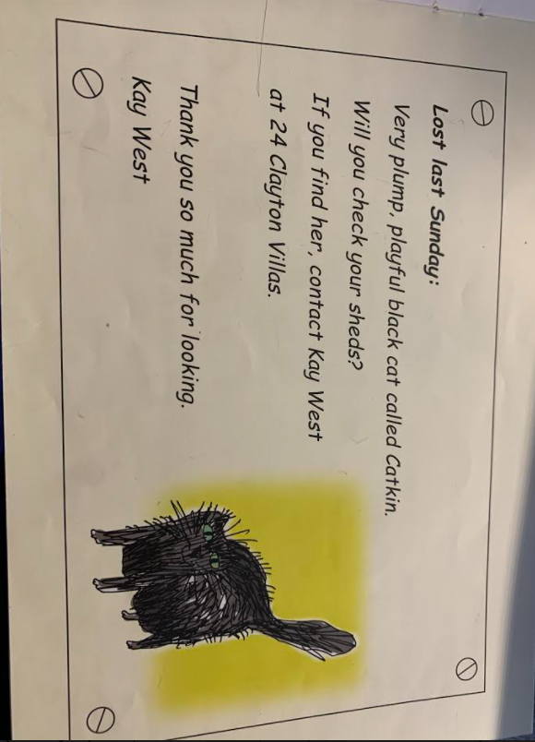
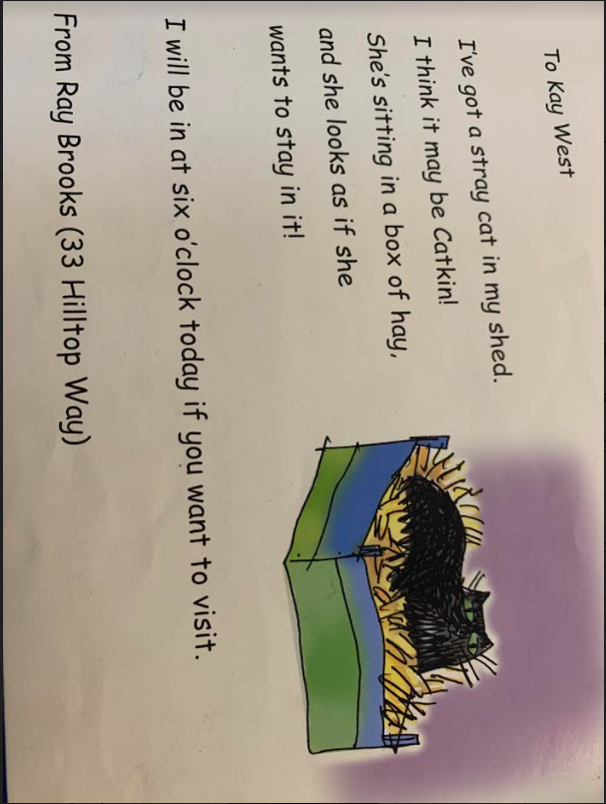

Read these sentences and fill in the missing words, use the text to help you.

I have got a ________ in my shed.

I think it maybe a ____________.

She is sitting in a _____________ of hay.

