Forgiveness

Christians believe God forgives people who are sorry for bad things they have done.

Christians believe this is what Jesus said, written down in the bible by one of his disciples:

Luke 6:37-38
³⁷ “Don’t judge other people, and you will not be judged. Don’t accuse others of being guilty, and you will not be accused of being guilty. Forgive other people, and you will be forgiven. ³⁸ Give, and you will receive. You will be given much. It will be poured into your hands—more than you can hold. You will be given so much that it will spill into your lap. The way you give to others is the way God will give to you.”

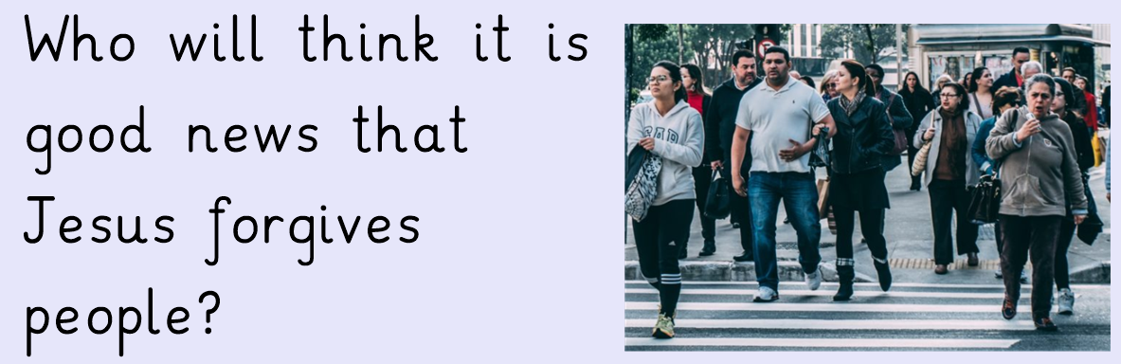

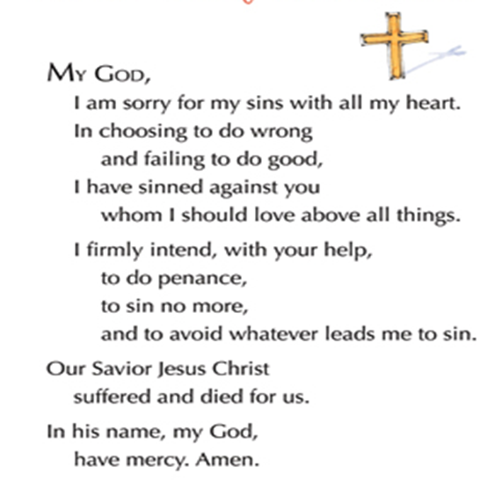
A prayer some Christians say when they are sorry for something they have done.

