RE

Memory recall challenge

Number the pictures in the order that they happened in the story of Noah.

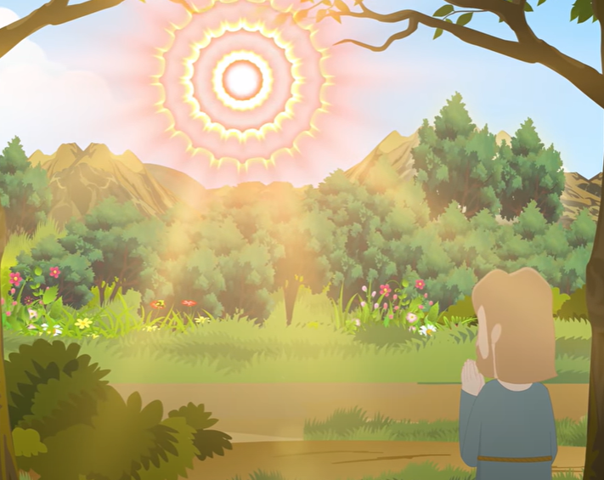

God told Noah what he was going to do.

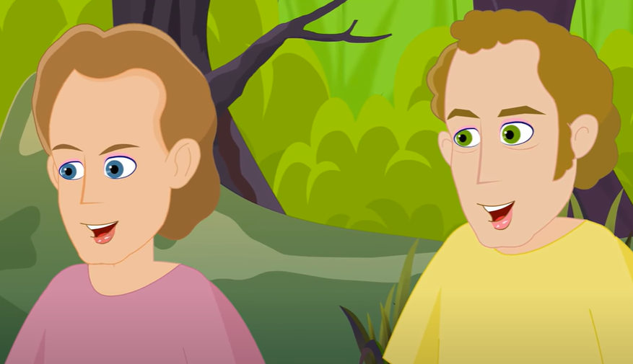

The people laughed when Noah started to build a boat.

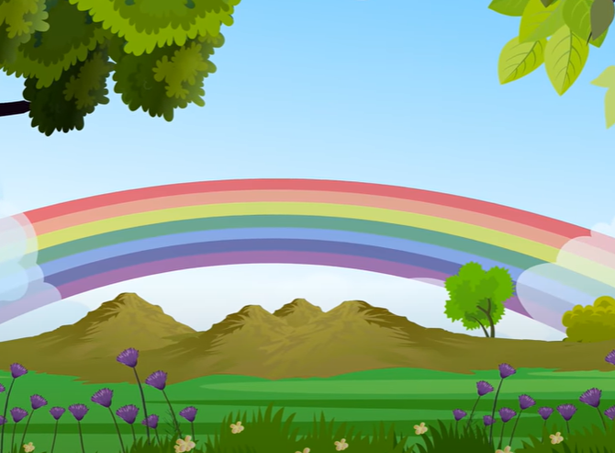

The rain stopped and God promised to never send a flood again as long as Noah and his family followed God.

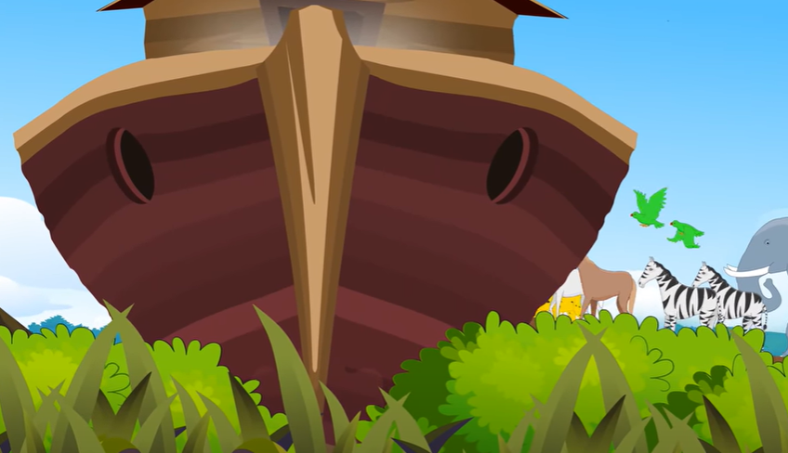

The animals and Noah’s family were safe on the boat.

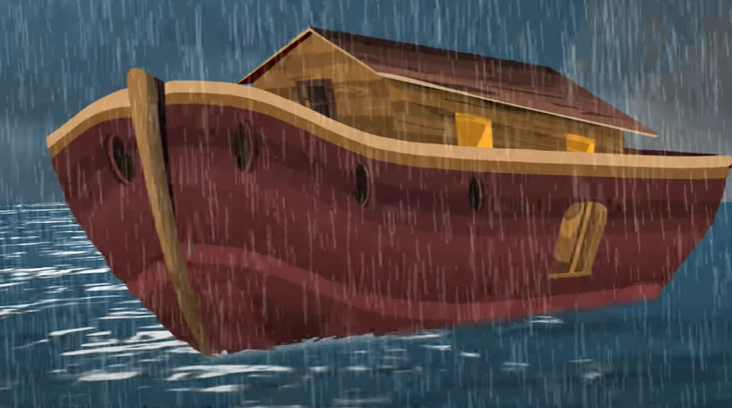

It rained for 40 days and nights.

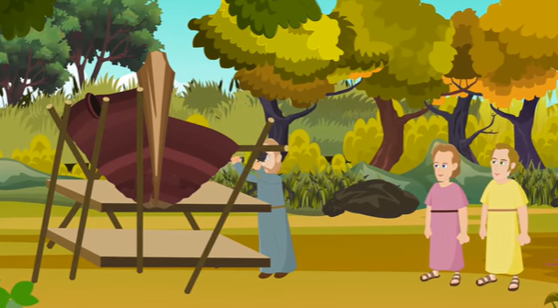

Noah started to build a boat.