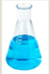
WC 18th January 2020
LI: To describe and compare the physical properties of materials
I can use the word opaque to describe materials accurately.
I can use the word transparent to describe materials accurately.
I can sort everyday materials into categories using their properties

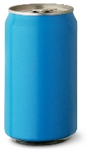  Opaque | 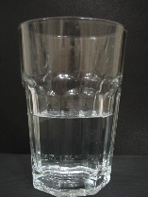  Transparent
Challenge: Fill in boxes with objects that are made of glass and wood and explain which objects are Opaque. Explain your answer.
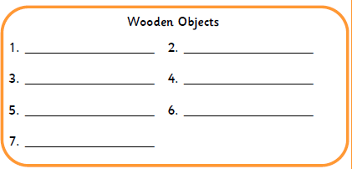
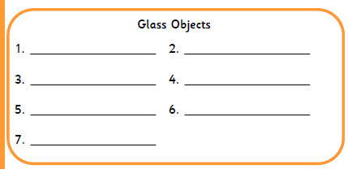
Explain your answer:

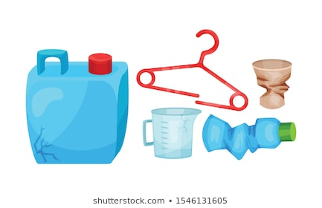
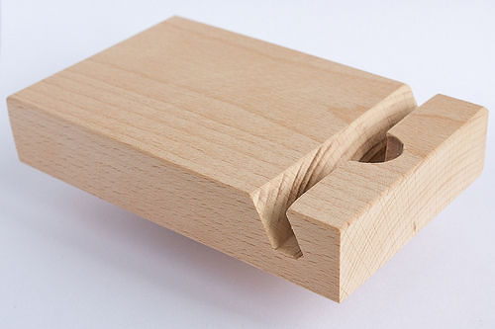
Wood
Plastic
Metal
Glass
Water
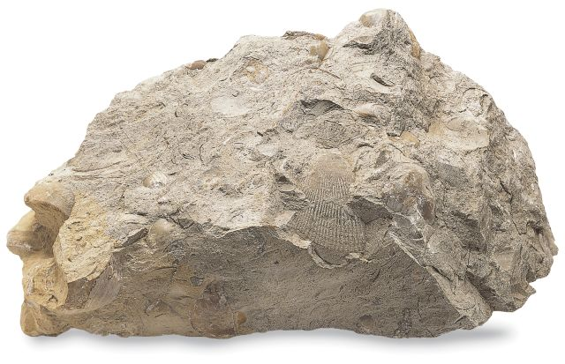
Rock
