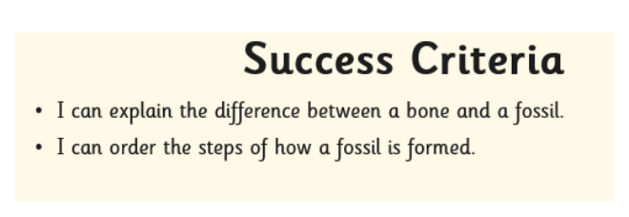

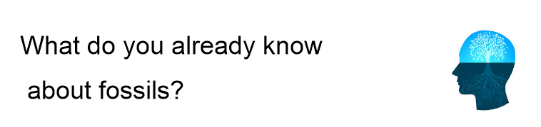

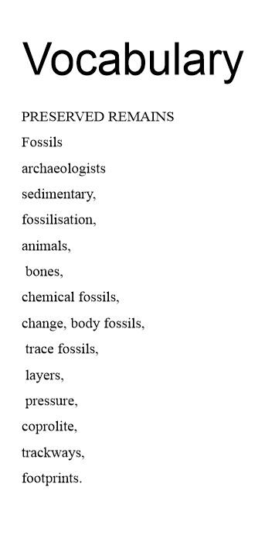

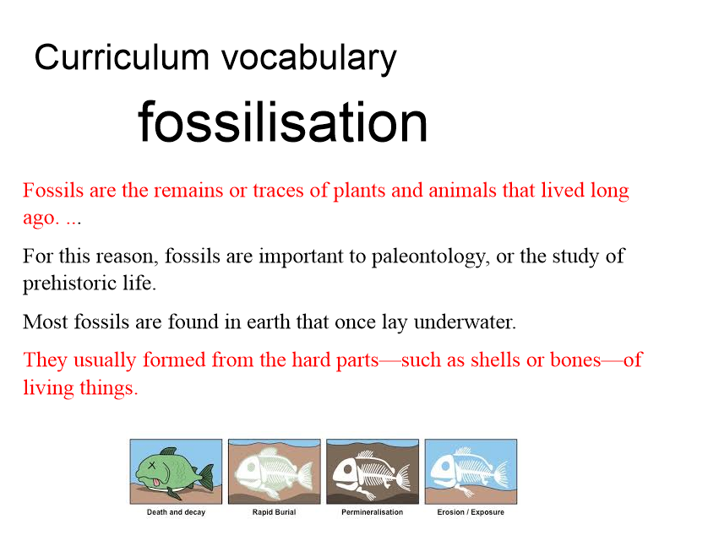

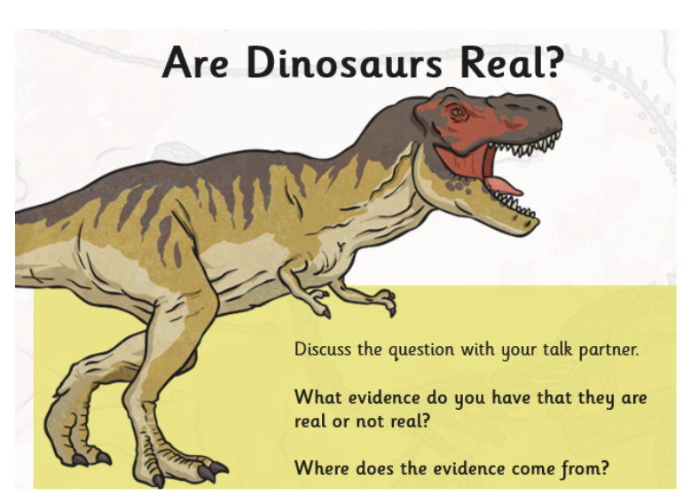

How do we know that dinosaurs were real?

What is the evidence?

Fossilisation Process

|  |  |
| --- | --- |
|  |  |
|  |  |
|  |  |
|  |  |
|  |  |

**Create a chronological report, iMovie, Book Creator or Stop Motion to show this process!**