Information sheet for Science Lesson 2 (14th January 2021)
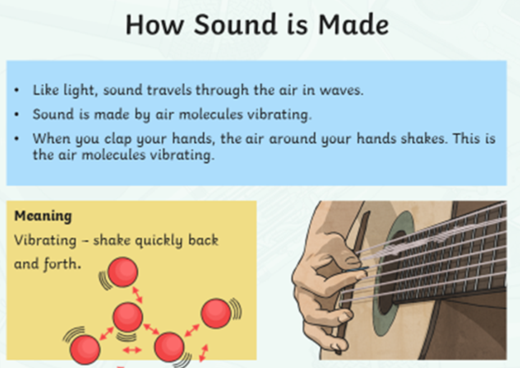

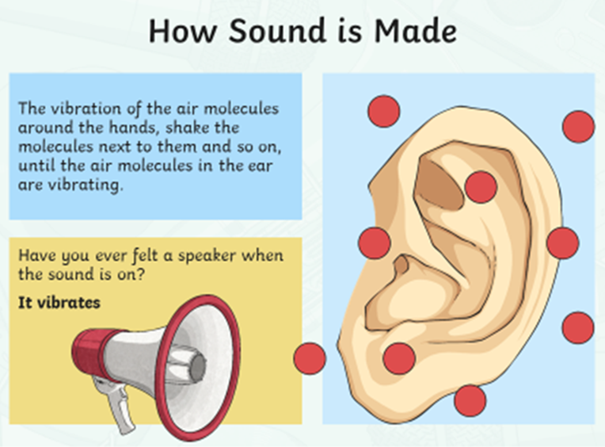

Below are some websites that help explain how sounds are made:
https://www.bbc.co.uk/bitesize/topics/zgffr82/articles/zstr2nb
https://www.bbc.co.uk/bitesize/topics/zgffr82/articles/zx9hcj6

