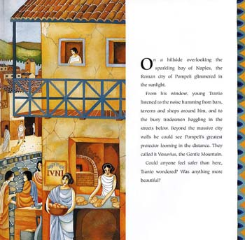
Content Domains: 2b, 2d

Retrieval
What I know

Inference
What I think

