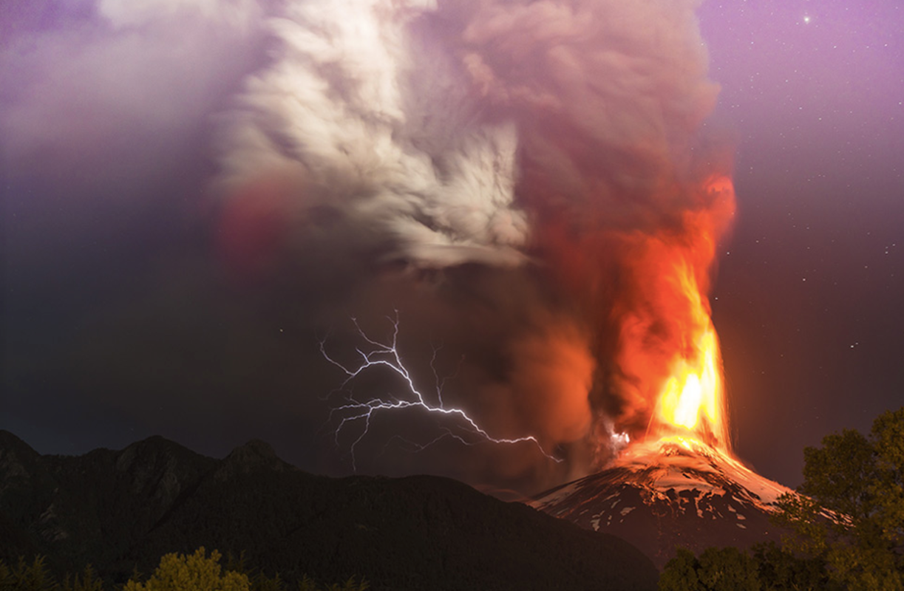
Create a 10 line poem about the volcano.
Use a mixture of words, phrases and sentences.
You can use the word bank to help you if you need to.

LI: to be able to innovate a descriptive poem
I will be successful if:
- I can select descriptive words, phrases and sentences
- I can organise my poem in the way I choose, making precise choices
- I can use my own descriptive words, phrases and sentences

