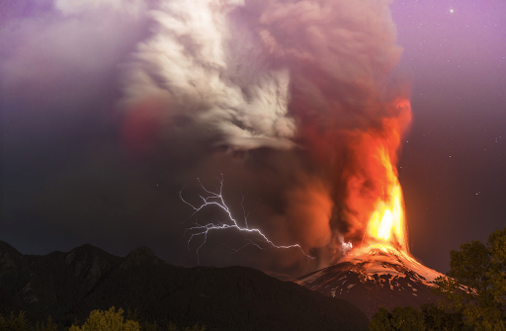
Volcano Word Bank

Word | Phrase | Sentence
Explode  Erupt  Chaos  Danger  Fury  Fierce  Deadly  Destroy  Catastrophe  Death  Malicious  Malevolent  Ancient  Monstrous  Vicious  Menacing  Furious  Malice  Fumes  Smoke  Ash  Smouldering | Towering majestically  Dominating the landscape  Guttural rumbling echoing  Overseeing its treacherous territory  Deafening boom  Death rained from the sky  Rose up malevolently  Looming ominously  Choking fumes  Fountain of fire  Black haze  Hissing steam  Cauldron of doom  Shrouded in mist  Pierced the sky  Slashed the land  Erupted in sharp peaks  Huge and hostile  Smoke rising  Ash tumbling  Lava spewing | Hurtling scorched rock and ash into the air  Choking the air with its impenetrable, sinister fumes  The world trembled and shook viciously signifying danger  Black clouds blocked out the sun, and darkness fell  Boulders cascaded down, destroying everything in their path.  A deafening boom echoed around the barren landscape  Red hot lava cascading down, a fiery tongue eating the world  A silent watchmen ready for action  Enveloped in thick, deadly clouds like a funeral cloak  The world was split and cracked by the power of nature  Ash drifted down and covered the world like a suffocating blanket  Lava descended, winding its way down the barren and hostile land

