Skill Check: Retrieve and Record Information (2b)
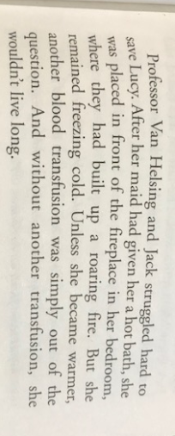
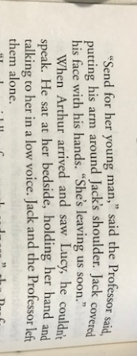
True or false?
 | True | False
The two men tried to save Lucy.

The cook tried to warm up Lucy.

A transfusion would save Lucy.

Arthur saw Lucy and began to cry.

Jack and the Professor stayed with Lucy.

Question Time
How does Van Helsing suggest they support Lucy whilst she is ill?
___________________________________________________________________________
How does Jack feel after writing the letter?
Explain your answer clearly and justify it using the text?
___________________________________________________________________________________________________________________________________________________________________________________________________________________________________________________________________________________________________________________________________________________________________________________________________________________________________________________
What causes Arthur to be filled with hope?
___________________________________________________________________________
Name 2 ways in which Lucy has changed after she wakes up.
___________________________________________________________________________
Page 59. Jack stared in astonishment. What makes Jack do this?
___________________________________________________________________________
What is significant about Lucy throwing away the crucifix?
___________________________________________________________________________
What makes Arthur bewildered and angry at Van Helsing?
___________________________________________________________________________
How do we know the real Lucy returns? Give two points of evidence.
___________________________________________________________________________
___________________________________________________________________________
Infer it!
Why does Van Helsing whisper this is just the beginning? Predict what Van Helsing thinks is going to happen.
_____________________________________________________________________________________________________________________________________________________________________________________________________________________________________________________________________
Compare and Contrast the two Lucy’s. How is the fake Lucy different to the real Lucy?
_____________________________________________________________________________________________________________________________________________________________________________________________________________________________________________________________________

