Thursday 14th January 2020
Content Domain: 1a draw on knowledge of vocabulary to understand texts
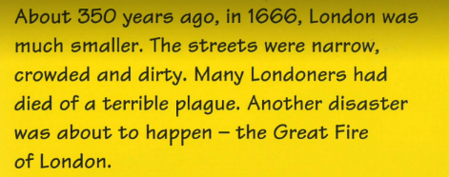
Read the text in the yellow box then talk about the words in the table. Draw a picture to help you remember what the words mean
Word | Picture
narrow
crowded
disaster

