Word | Verb, adjective or noun | Picture
narrow
crowded
disaster
plague
Thursday 14th January 2020
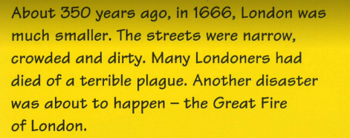
2a Give / explain the meaning of words in context

