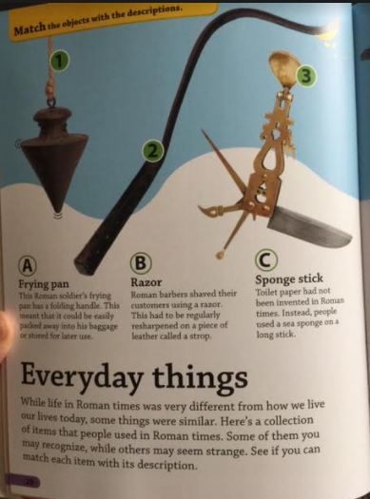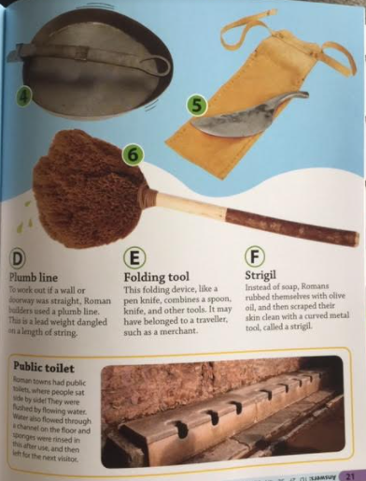
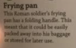
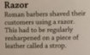
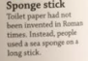
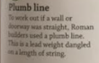
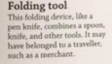
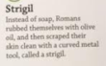
Thursday 28th January
Everyday Things
Match the item to its description
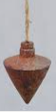
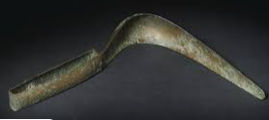
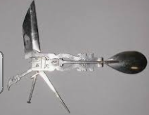

Read the text box ‘Public Toilet’
Explain how Roman toilets worked.
____________________________________________________________________________________________________________________________________________________________________________________________________________________________________________________________________________________________________________________________________________________________________________________________________________________________________________________________________________________________________________________________________________________________________________________________________________________________________

