Thursday 4th February
LI: to be able to identify and use prepositions of place
I will be successful if:
- I can recall prepositions of place
- I can identify prepositions of place
- I can use prepositions in my sentences
What is a preposition of place?
_____________________________________________________________________
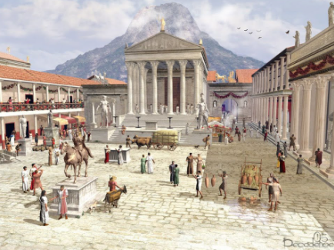
Where are the people?

Where is the volcano?

Where are the buildings?
Thought shower- list as many prepositions of place as you can think of.

Choose the correct preposition.
The birds are __________ the ancient, cracked buildings.
Fish swam ___________ the old, wooden boat.
Lucas is stood __________ to the harbour wall.
The people of Pompeii walked ___________ the narrow, dusty streets.
Lucas was stood ______________ the statue and the bakery.
next | along | above | between | beneath

Identify the prepositions in the sentences.
Lucas was sat on his old, wooden fishing boat as it bobbed gently on the glistening, sparkling sea. Above him, the birds circled overhead, diving in and out of the beautiful clouds. From over the water, Lucas could see the fisherman unloading their catches onto the harbour and carrying them along the dusty narrow streets. The golden sun shone down onto Pompeii and made it gleam majestically.
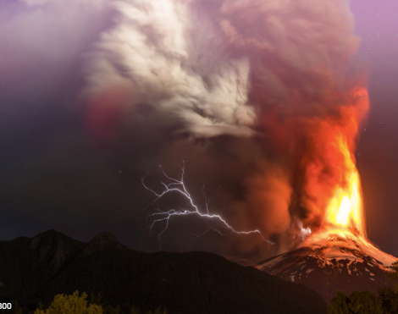
Sentence Creator- describe the scene using prepositions (above, below, in, on, over, down, beneath)
______________________________________________________________________________________________________________________________________________________________________________________________________________________________________________________________________________________________________________________________________________________________________________________________________________________________________________________________________________________________________________________________________________________________________________________________________________________________________________________________________________________________________________________________________________________________________________________________________________________________________________________________________________________________________________________________________________________________________________________________________________________________________________________________________________________________________

