Thursday 28th January
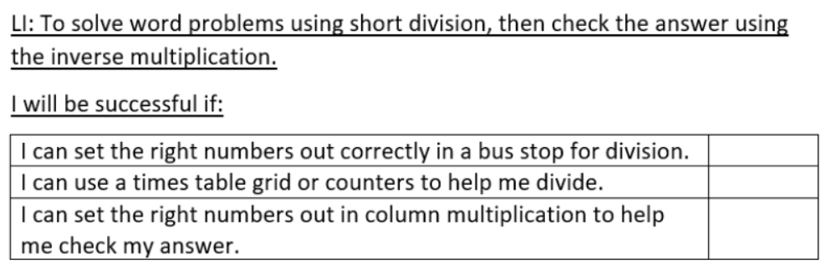
Use short division to work out the answers to these word problems. Then use the inverse multiplication to check that your answers are correct.
1. I have 726 cupcakes to sell at the fair. The fair lasts for 3 days. How many do I want to sell each day?
2. There are 484 children in the school. They need to be split into 4 groups. How many children will there be in each group?
3. Five hundred and nineteen penguins need to be put into 3 pools. How many will go in each pool?
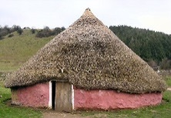
4. There are 847 Anglo-Saxons living in 7 villages. How many live in each village?
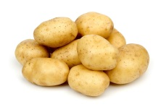
5. There are 964 potatoes in the bags and 4 enormous pans in the kitchen. How many potatoes will the chef put in each?
6. There are 309 paint brushes in the cupboard and 3 trays for them. How many paint brushes should go in each tray?
7. 428 children need to go to the theatre. Four buses are sent to take them there. How many children should go on each bus?
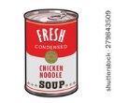
8. A supermarket has 4 shelves for soup and 564 tins to put on them. How many tins should they put on each shelf?

