Thursday 28th January
Instructions
Read the word problem and highlight the key information.
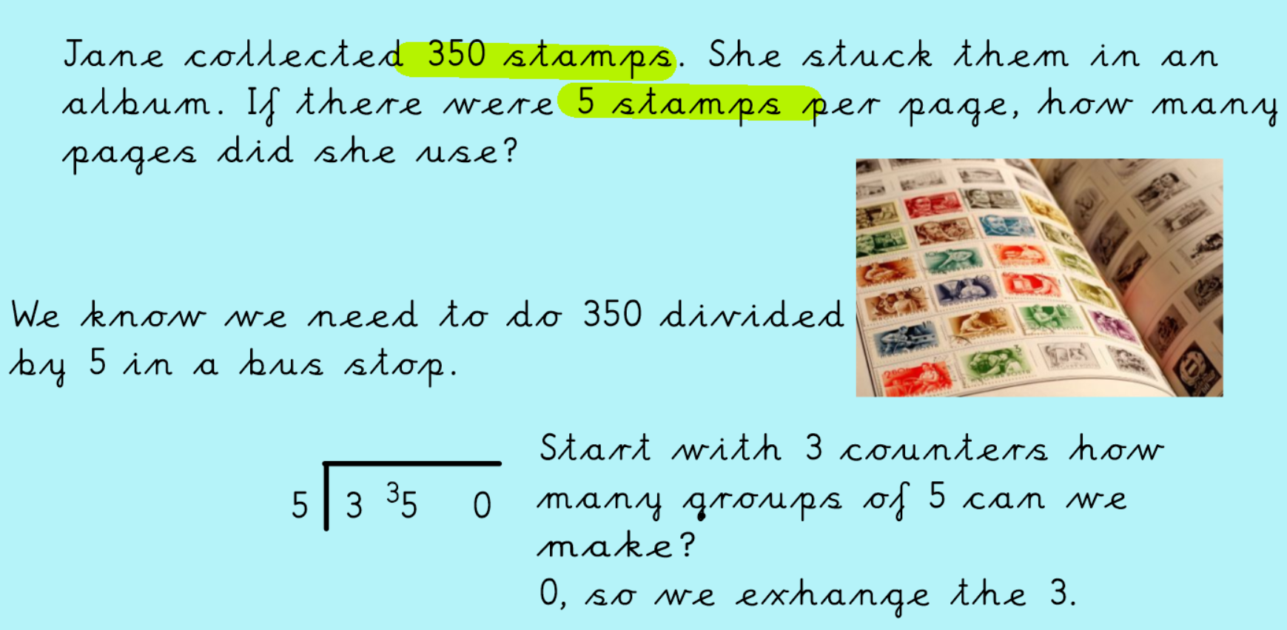
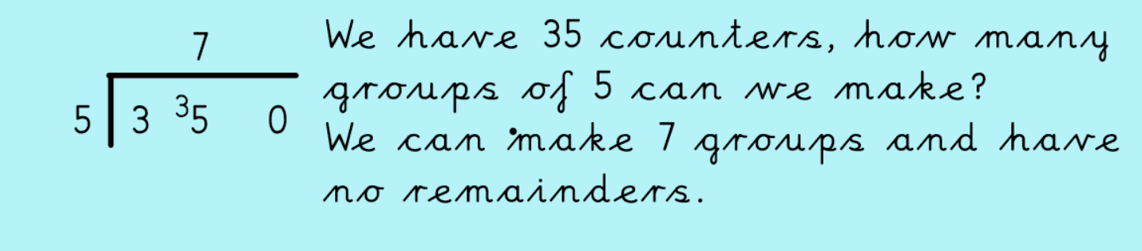
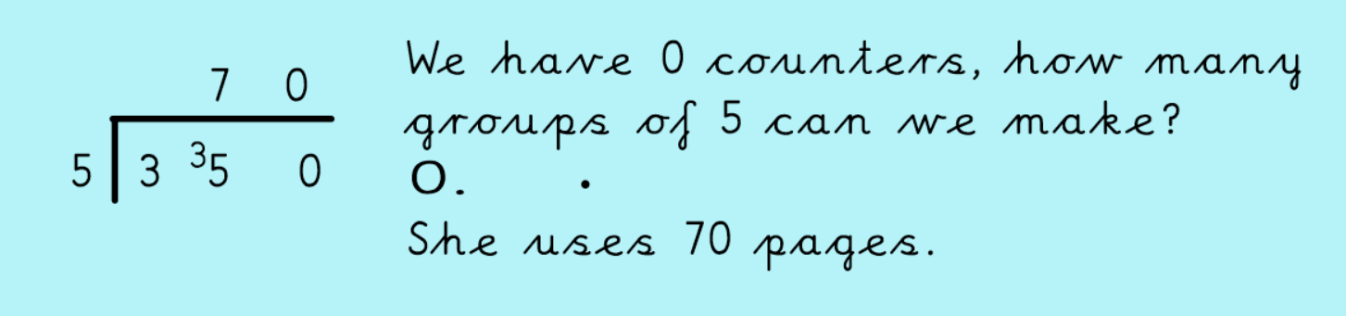

Now check your answer using multiplication.
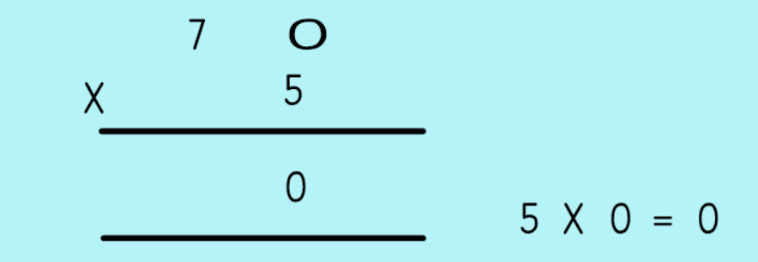
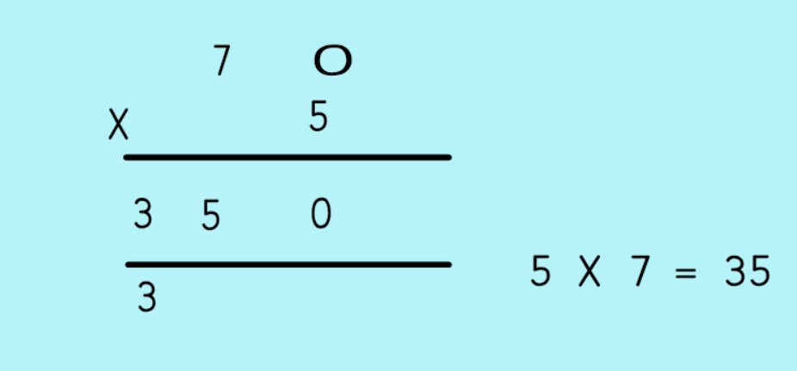

Now have a go at the word problem activity.

