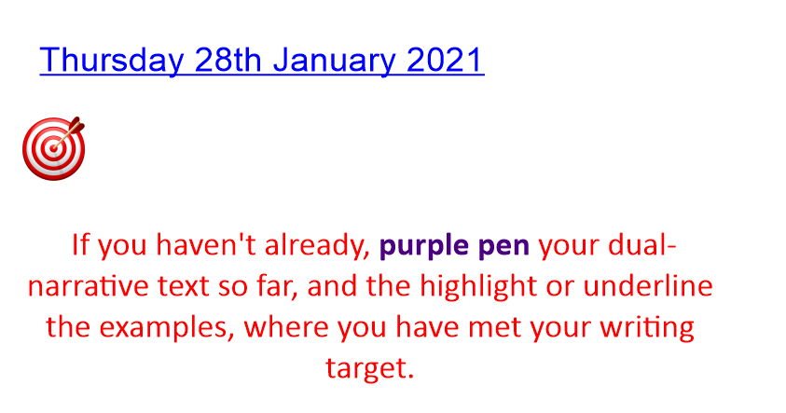
Look back at your plan from yesterday.
Create a word bank for your new laboratory setting.
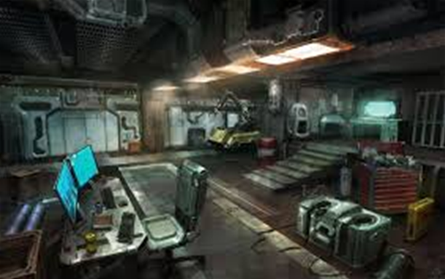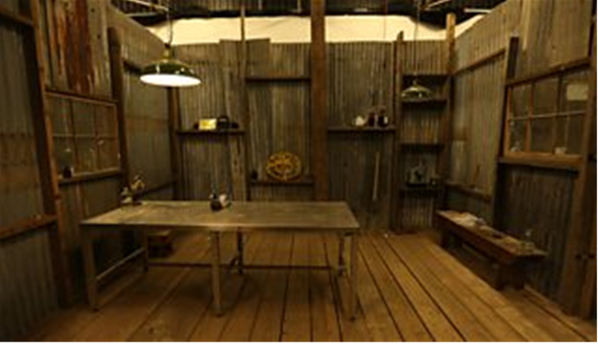
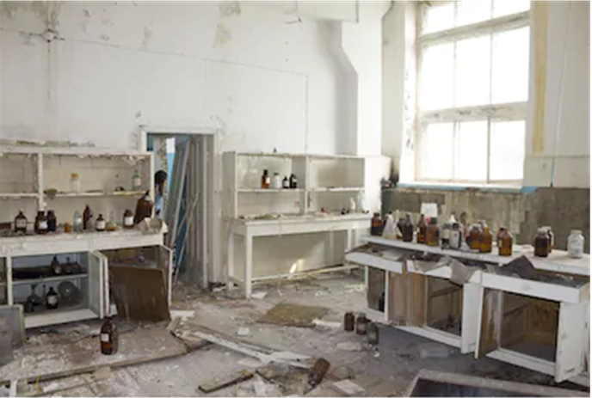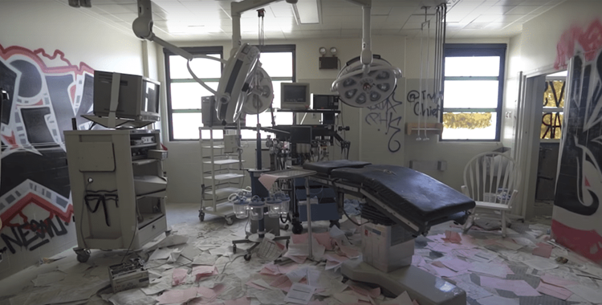
Verbs | Adverbs | Adjectives | Nouns

Now, we are going to look to write the second part of our innovated dual-narrative:

Action Points

1. Describe what your dream was.
2. Explain why you wanted to create your creation
3. Describe what you did to create your creation.
4. Explain how you brought your creature to live- what did you do?
5. Describe what your creature looked like
6. Explain how you felt when you saw it

Look back at your WAGOLL of Frankenstein to support your writing.

