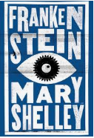
Li: to be able to plan, draft, evaluate and edit an opening of a dual perspective narrative (imitation)
I will be successful if:
- I can recall and plan the key events which happen in the narrative opening
- I can use a range of subordinating and co-ordinating conjunctions
- I can use a range of sentence types (fronted adverbials, expanded noun phrase, prepositional phrases, relative clauses)
- I can use speech and speech punctuation
- I can use adverbs for time and detail
- I can use parenthesis (colon, semi colon, brackets and dashes)

Today, we are going to write the second part of our dual-narrative.
Read the Frankenstein WAGOLL for the second section (N2).

N2: You see, Captain Walton (he said) I once had a dream. I dreamt I’d use my scientific knowledge and skill to create an entirely new kind of being, one that would never suffer illness or death. I believed this journey of mine into the unexplored reaches of science would bring great and wonderful things to mankind…how foolish I was.
I dreamt I’d become famous, rich and respected for the great gift I had given the world. My name is Victor Frankenstein. I had heard of men, who’d made major scientific discoveries and had peered into the hidden depths of nature. How I longed to be one of these men! I was soon aflame with one singular thought, one idea, one purpose. I wanted to go further, be greater than all before. I would create life itself!
I spent days, night, months, years, studying life and death, until I could make life. I made dead matter become alive again. What an astonishing power I held in my hands! I went to graveyards, mortuaries and hospitals gathering (in the dead of night) all the matter I would need. I lost all idea of the outer world, so consumed with my task I became. I didn’t eat or sleep. I soon became pale and thin, but my ambition was enough to drive me forward. A year passed, until I had completed my challenge. In my laboratory, I had formed a completely new being, out of dead matter.
It was a dreary night in November with rain pattering dismally against the panes. I collected the scientific instruments for giving life around me. The lifeless thing I’d created lay at my feet. Now to send the electric spark into it, and bring it alive. It was one o’clock in the morning - my candle nearly burnt out - before the glimmer of its failing light showed me the dull yellow eyes of the creature open for the first time. It breathed hard. A great jerk and shudder shook its vast limbs.
I stared in utter horror; with such care and patience I’d tried to create this being! Every part of him fitted his great size. I’d chosen his features in the hope they’d be beautiful. Beautiful!? His muscles and veins were barely covered by his yellow skin. His hair was shiny black and flowing. His teeth were pearly white.
But all was only the more horrible against his watery yellow eyes, his shrivelled skin, his straight black lips. An Egyptian mummy brought to life wouldn’t be as hideous as that Thing. I’d gazed on him when he was unfinished, and he was ugly then. But when those muscles and joints were able to move, he became… a Thing of Nightmares.
The beauty of the dream that had filled my life for two years evaporated. Only shock and disgust tortured me. It was a grotesque, unnatural thing that lay before me. I couldn’t look at it.
I fled from the laboratory.

What are the key action points in the second part of the narrative?
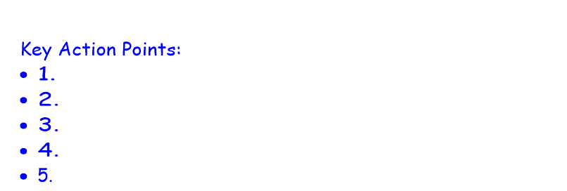

Sign in to live learning to do shared planning and writing with Mr Brownsell.
Now, write your second part of the narrative.

